**Vietnam General Confederation of Labor**

**TON DUC THANG UNIVERSITY**

**FACULTY OF INFORMATION TECHNOLOGY**



**FINAL REPORT**

**WEB AND APPLICATION PROGRAMMING**

**MUSIC WEBSITE BY HTML, CSS, JS, PHP**

*Instructor*: **Mr. PHẠM THÁI KÌ TRUNG**

*Student*: **PHAN THÀNH ĐẠT - 521H0218**

**NGUYỄN LÊ PHƯỚC TIẾN - 521H0514**

*Year* **: 2022-2023**

**HO CHI MINH CITY, 2023**

Vietnam General Confederation of Labor

**TON DUC THANG UNIVERSITY**

**FACULTY OF INFORMATION TECHNOLOGY**



**FINAL REPORT**

**WEB AND APPLICATION PROGRAMMING**

**MUSIC WEBSITE BY HTML, CSS, JS, PHP**

*Instructor*: **Mr. PHẠM THÁI KÌ TRUNG**

*Student*: **Phan Thành Đạt - 521H0218**

**Nguyễn Lê Phước Tiến - 521H0514**

*Year***:2022-2023**

**HO CHI MINH CITY, 2023**

ACKNOWLEDGEMENT

We want to give to Mr. Pham Thai Ki Trung sincere thanks, who enthusiastically taught and worked very hard to give us to have enough knowledge and skills to complete this report. And we want to give thanks for Tôn Đức Thắng University, when this place give me an opportunity to follow up with large exercises so that we can consolidate the knowledge learned through the lectures.

*Ho Chi Minh city, 7th May, 2023*

*Author*

*(Sign and write full name)*

*Đạt*

*Phan Thành Đạt*

*Tiến*

*Nguyễn Lê Phước Tiến*

**THIS PROJECT WAS COMPLETED AT**

**TON DUC THANG UNIVERSIY**

I fully declare that this is my own project and is guided by Mr. Pham Thai Ki Trung; The research contents and results in this topic are honest and have not been published in any form before. The data in the tables for analysis, comments and evaluation are collected by the author himself from different sources, clearly stated in the reference section.

Besides that, the project also uses a number of comments, assessments as well as data from other authors, other agencies and organizations, with citations and source annotations.

**Should any frauds were found, I will take full responsibility for the content of my report.** Ton Duc Thang University is not related to copyright and copyright violations caused by me during the implementation process (if any).

*Ho Chi Minh city, 7th May, 2023*

*Author*

*(Sign and write full name)*

*Đạt*

*Phan Thành Đạt*

*Tiến*

*Nguyễn Lê Phước Tiến*

CONFIRMATION AND ASSESSMENT SECTION

**Instructor confirmation section**

_______________________________________________________________________________________________________________________________________________________________________________________________________________________________________________________________________________________________________________________________________________________________________________________________________________

*Ho Chi Minh May, 2023*

*(Sign and write full name)*

**Evaluation section for grading instructor**

_______________________________________________________________________________________________________________________________________________________________________________________________________________________________________________________________________________________________________________________________________________________________________________________________________________

*Ho Chi Minh May 2023*

*(Sign and write full name)*

SUMMARY

This is the final project web and application programming about Music website Here we develop functions such as listening to music, downloading, etc. At the same time, we also develop a management system for managers where they can add, delete or edit songs. Users can also log in to access additional features such as adding songs to their favorites, commenting on songs, and more.

INDEX

CHAPTER 1 – INTRODUCTION 6

1.1 Project Overview 6

1.2 The reason for choosing 6

1.3 Function overview 7

1.4 Theoretical Basis 7

1.5 Analysis 9

CHAPTER 2 – DESIGN INTERFACE WEB(FRONT-END) 12

2.1 LOGIN AND SIGN UP 12

2.2 ADMIN PAGE 13

2.3 USER PAGE 15

CHAPTER 3 – BUILDING PAGE (BACK-END) 17

3.1 Database 17

3.2 Login Form 18

3.3 Admin form. 20

3.3.1 Categories 20

3.3.2 Songs. 25

3.3.3 Comment. 31

3.4 User Form. 34

CHAPTER 4 - CONCLUSION 52

CHAPTER 1 – INTRODUCTION

1.1 Project Overview

This is the last practical report for the course on website and application development. For this report, we created a music website that is comparable to well-known music websites like Spotify, Zing MP3, NhacCuaTui, etc. We will provide further information about our initiative in the area that follows.

1.2 The reason for choosing

My team's decision to develop a music website as our project might have been motivated by a number of factors. Among the explanations may be:

Interest in music: The team members' individual interests in music may have inspired them to create a website on it.

Popular topic: Music is a very popular topic that appeals to people of all ages and from all backgrounds. Consequently, a music website may be able to draw in a sizable audience.

Technical viability: A variety of technical abilities, including web development, database administration, and audio streaming, are necessary to build a music website. The group may have had faith in their capacity to acquire these talents and use them in a real-world endeavor.

Building a music website would provide the team members practical experience in web development and application programming, which would benefit both their education and future employment opportunities.

1.3 Function overview

The website will have some simple functions such as:

- Listen to music.

- Pause, skip , back music.

- Listen randomly, shuffle music

- Search the music

We also develop separate user and admin interfaces

For admins:

- Manage categories

- Manage songs

- User management ,comments

- Manage track listings on the homepage (top good songs, create monthly charts)...

For users:

- Like songs.

- Add songs to playlist.

- Comment.

**1.4 Theoretical Basis**

A music website's theoretical underpinnings may be found in a number of disciplines, such as musicology, media studies, cultural studies, and communication studies.

Musicology examines the creative and technical facets of music, including its harmony, melody, rhythm, and structure. It also looks at the sociological and historical background of the production and consumption of music. A music website can include these components by offering details on the background of various musical genres, bios of performers and composers, and analyses of musical creations.

Media studies look at how the media affects society and culture. They examine the creation, dissemination, and reception of media messages by audiences. By looking at how music is promoted and disseminated via various platforms, including streaming services, social media, and conventional record companies, a music website can contain elements of media studies.

The link between culture and power is explored in cultural studies, which also looks at how cultural items like music reflect and reproduce social structures. This viewpoint may be included into a music website by looking at the cultural relevance of various musical genres, the ways in which music reflects and upholds societal norms and values, and the ways in which music resists or challenges prevailing cultural narratives.

Communication studies look at the act of communicating itself, examining the encoding, transmission, and decoding of information for various audiences. By investigating how music conveys meaning, how listeners understand and react to music, and the function of music in promoting social connection and community development, a music website can contain components of communication studies.

**1.5 Analysis**

**User Analysis:**

A music website's success depends on the users' experience, so it is essential to understand their needs and expectations.

The user analysis would include:

Identifying the target audience: Who are the website's intended users? Are they music enthusiasts, professionals, or casual listeners?

Understanding user behavior: How do users interact with the website? What features do they use the most? What frustrates them?

User personas: Developing user personas can help create a better understanding of the target audience and tailor the website's content to their needs.

**System Analysis:**

A music website must function well from the technical point of view. A system analysis would involve:

Identifying the website's hardware and software requirements: What infrastructure is needed to support the site's functionality?

Analyzing the website's architecture: How does the website function and what systems are used to build and maintain it?

Identifying potential issues: What are the possible security, performance, and scalability concerns?

**Functional Analysis:**

Functional analysis involves identifying the website's features and capabilities and ensuring that they meet the user's needs. Key areas of focus could include:

Search functionality: Is the search feature easy to use and effective? Can users filter results by genre, artist, album, etc.?

Playlist creation: Can users easily create and save playlists, share them, and collaborate with others?

Music discovery: How does the website recommend new music to users? Are there curated playlists, personalized recommendations, or other features for discovering new artists and songs?

**Non-Functional Analysis:**

Non-functional analysis involves assessing the website's performance, security, and usability. Key areas of focus could include:

Speed and responsiveness: How quickly does the website load? Is it responsive on different devices and internet speeds?

Security: How secure is the website? Are user data and payment information protected?

Usability: Is the website easy to navigate, understand, and use? Are there clear calls to action and intuitive interfaces?

CHAPTER 2 – DESIGN INTERFACE WEB(FRONT-END)

2.1 LOGIN AND SIGN UP

-Login form:

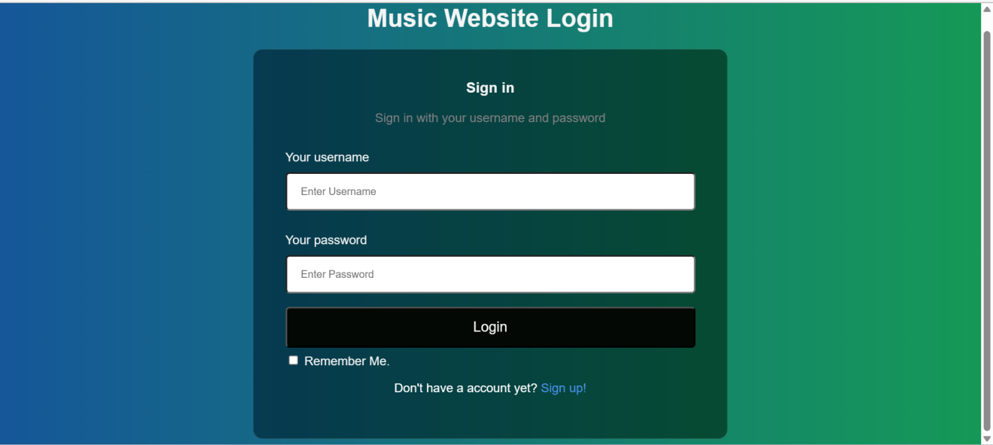

- Sign up form:

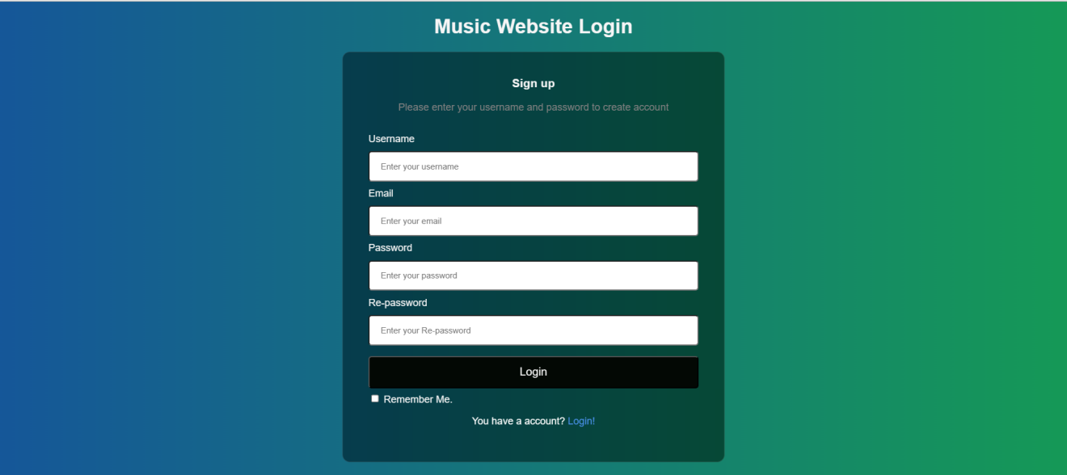

2.2 ADMIN PAGE

The admin page will allow Admin to control all activities of the website, and below will be the interface of the admin.

**Manage track listings:** This page will let admin know which songs are top good songs, besides it will create create monthly charts

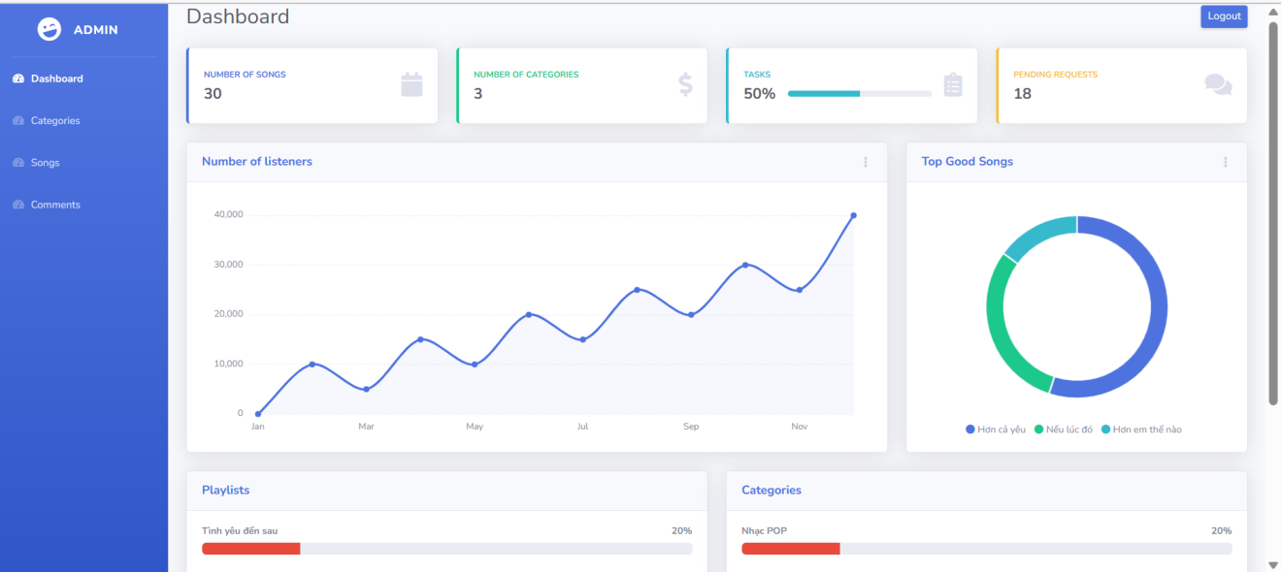

**Manage songs:** This page will let the admin manage the existing songs here, including the functions of adding, deleting, and editing songs.

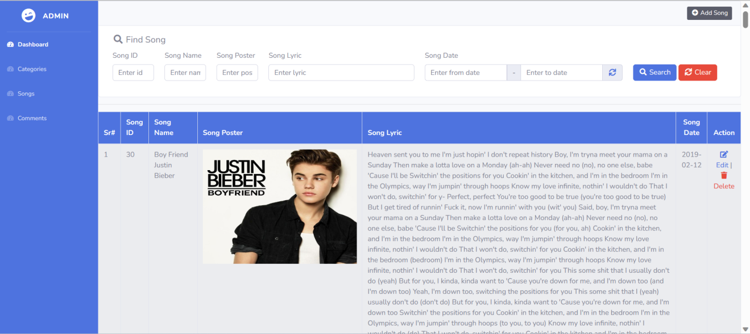

**Manage categories:** This page will let the admin manage the music genres on the website, including the functions of adding, deleting, editing.

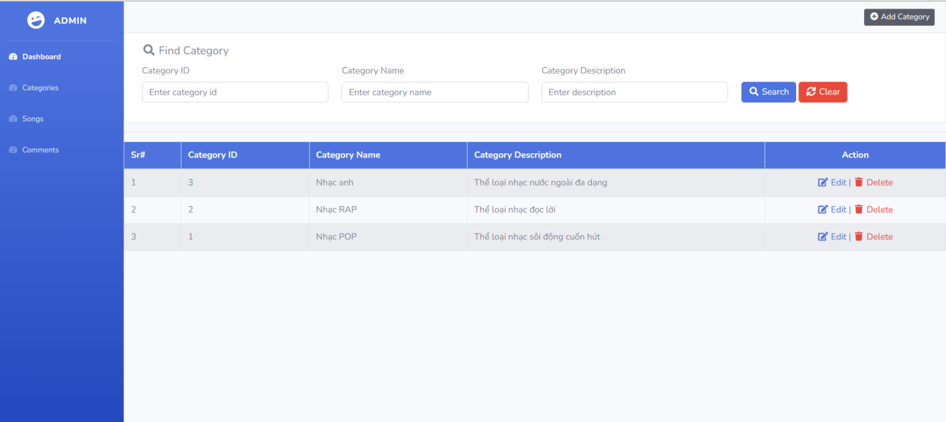

**Manage comments:**This page will let admin manage user comments about songs.

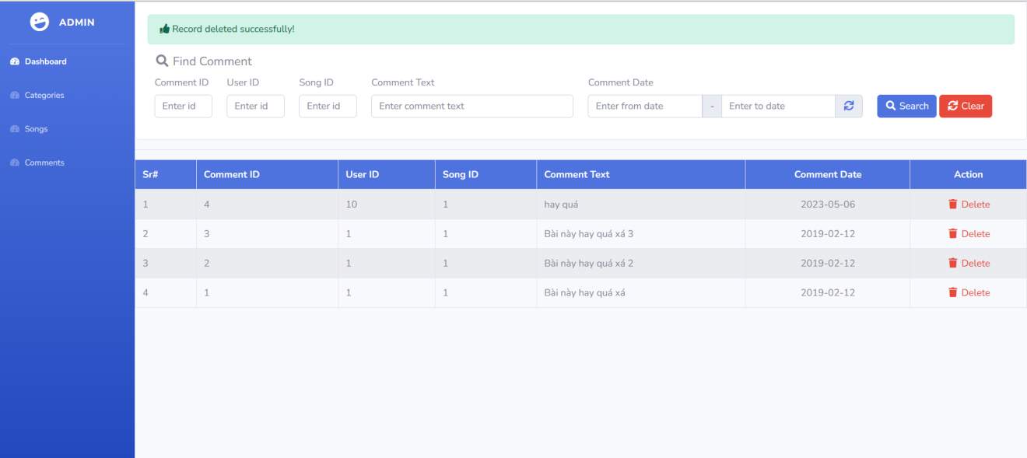

2.3 USER PAGE

**Home Page:** This is the user interface when logging into the website, here will show songs of genres like VPOP, or USUK.

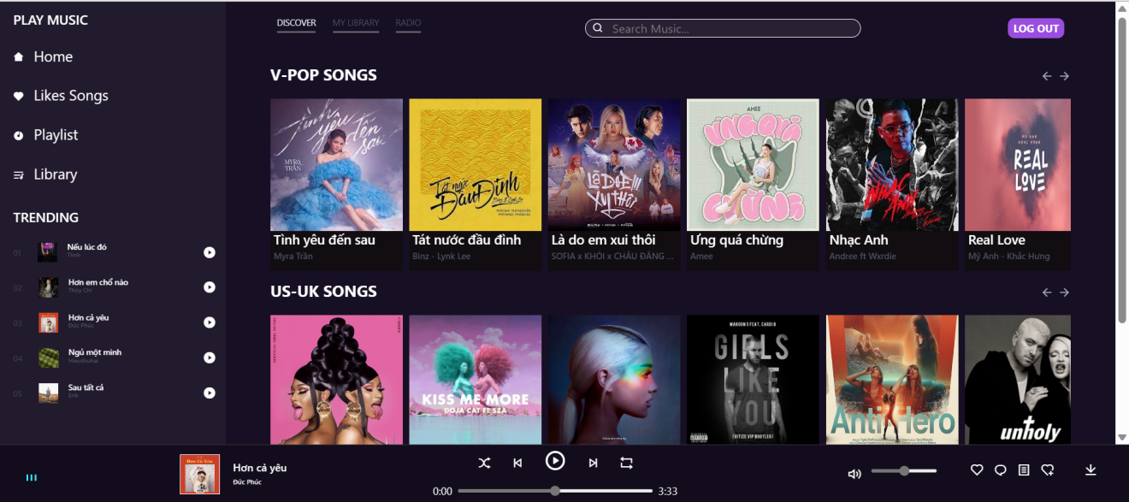

**Favorite songs Page:** Songs that are liked by users will be transferred to this page

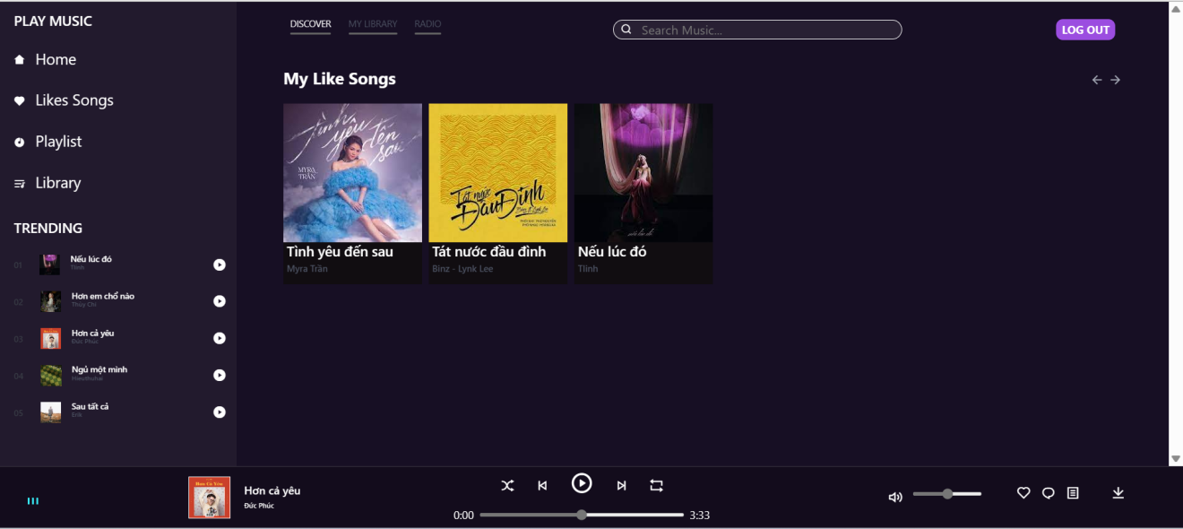

**Playlist page:**this site allows you to create your own playlist.

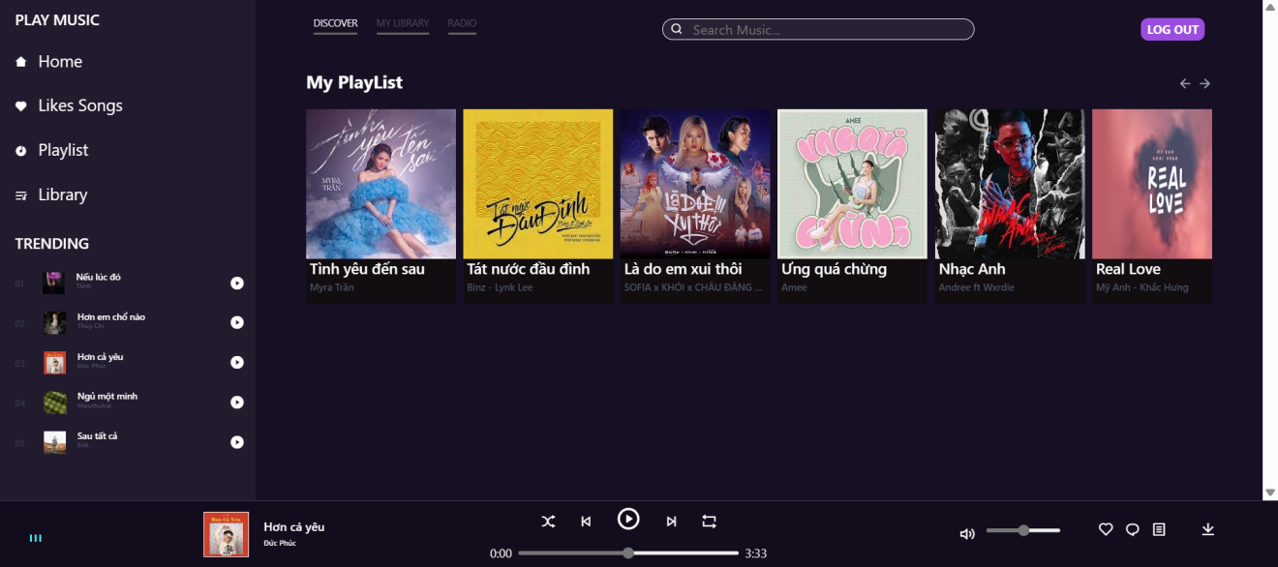

**Library page:** The songs you just listened to will be saved to this website.

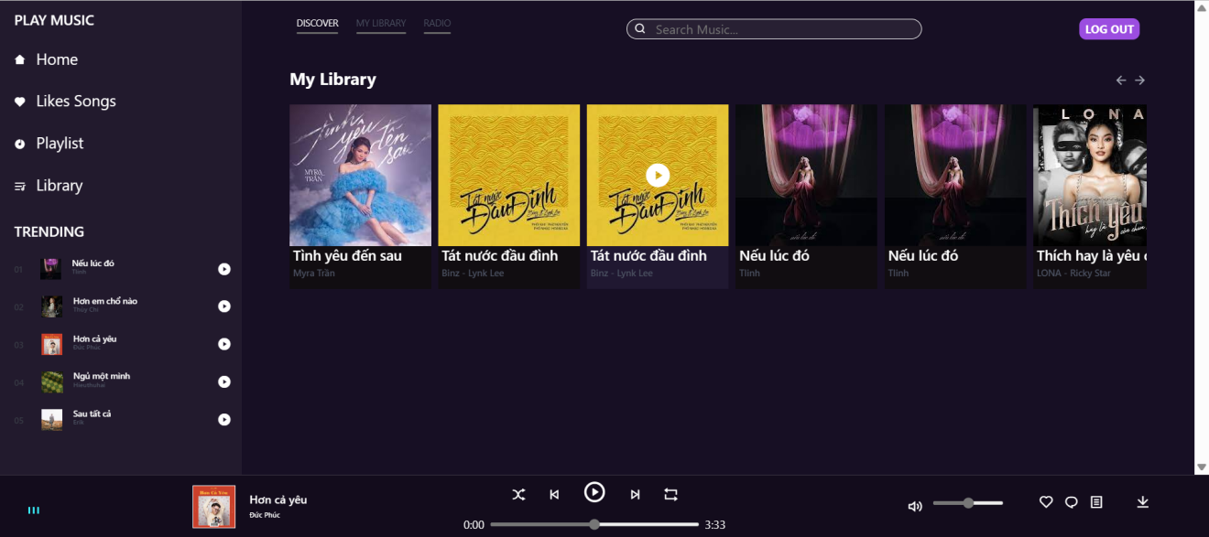

CHAPTER 3 – BUILDING PAGE (BACK-END)

3.1 Database

Use XAMPP, the database management system(phpMyAdmin) to create tables to manage music websites.

**Includes tables:**

Active: Save information which user is active.

Active_song: Save information which music is being listenned.

Category: Save information about music genres.

Comment: Save information about comment of user.

Library: Save information about previously heard song.

Likes: Save information about the song has been liked by the user

Playlist: Save information about the song has been added to their playlist

Replies: Save reply of user

Users: Save account of users

**Below is all the information of the tables in the database:**

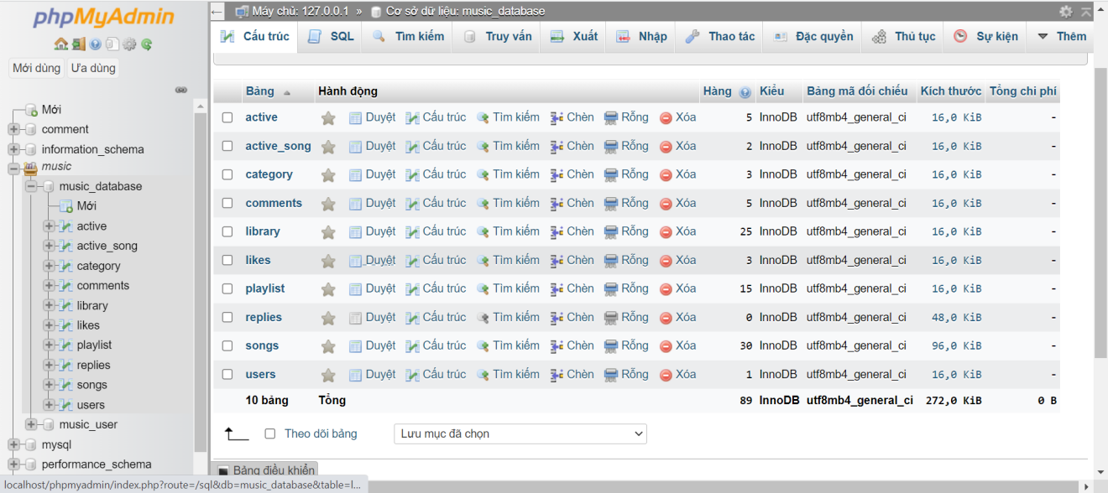

3.2 Login Form

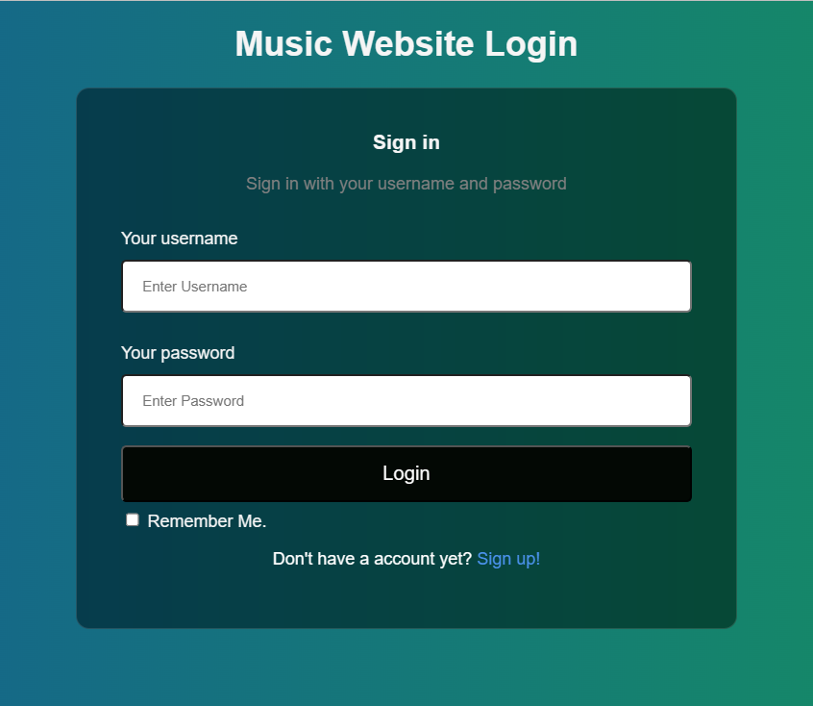

**Code:** The code will check if the database has a user and password that the user entered and there are 3 cases: the first is to enter the admin account, then the user, and finally the wrong account.

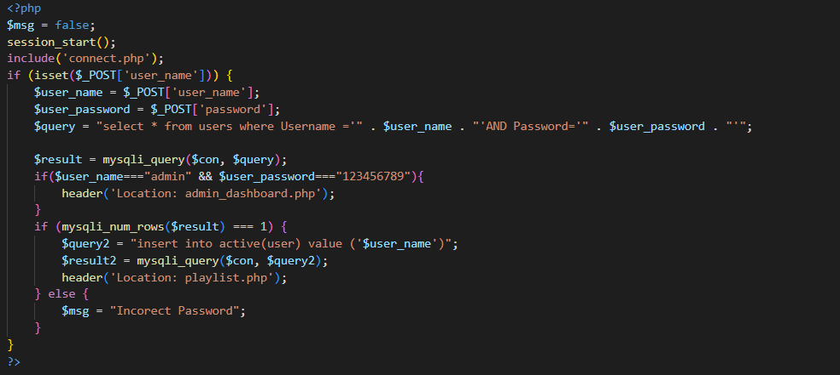

**Case 1:**

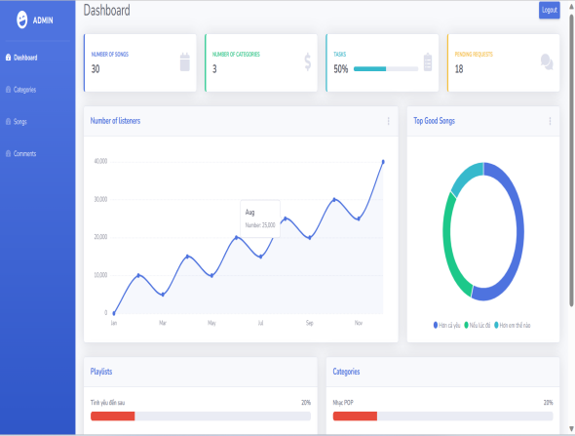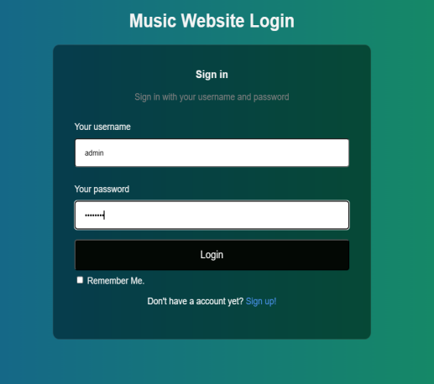

**Case 2:**

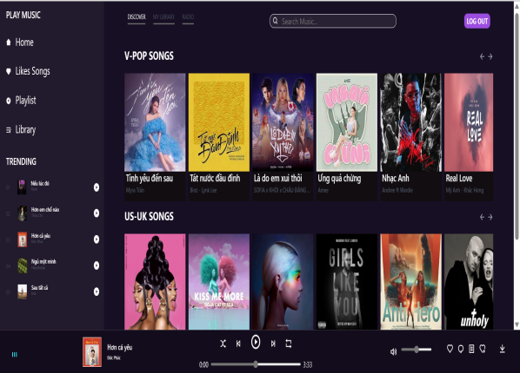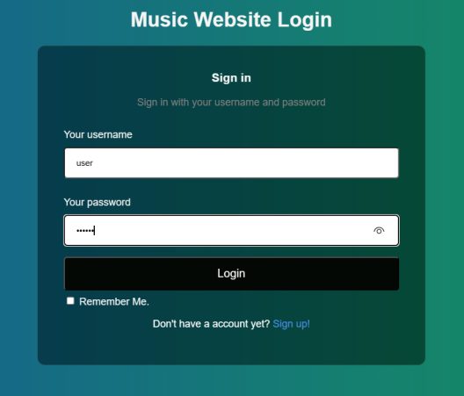

**Case 3:**

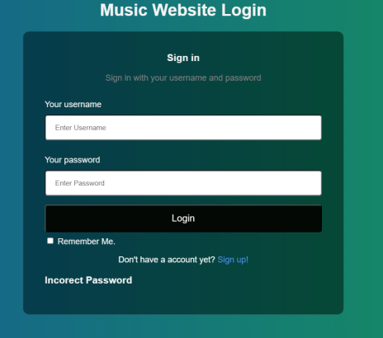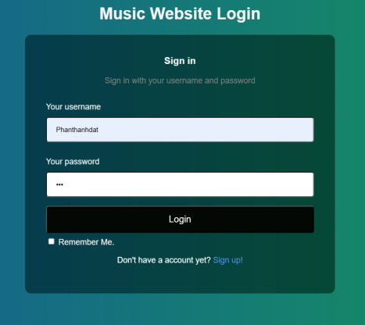

**3.3 Admin form.**

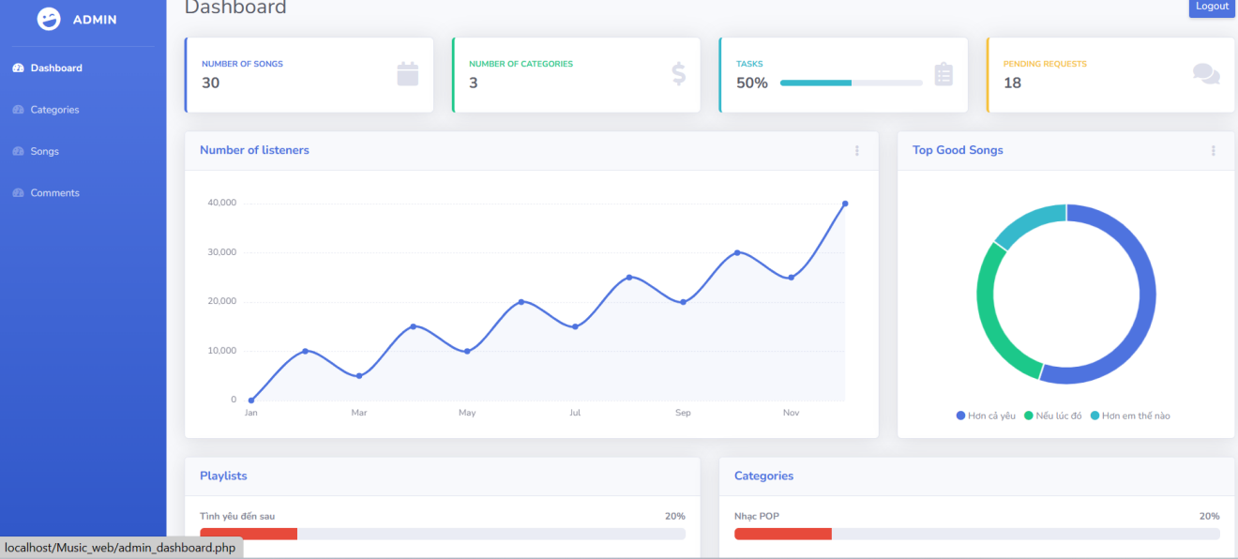

**Code:** admin_dashboard.php (The code is quite long, so I just put the file name containing the code).

In the dashboard, we can see the number of songs, the number of genres, and the top good songs. In here we also designed 3 more functions for admin that are managing categories, songs and comments.

**3.3.1 Categories**

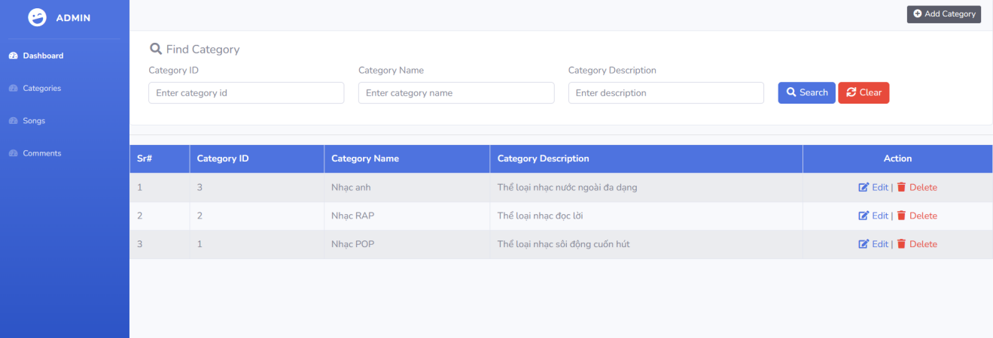

**Code:** admin_category.php

We have 3 functions which are search, add, edit and delete in here.

1. **Search**

To start with, with Search we have search by id , category name, category, description. Below is example image for search.

**Search by id:**

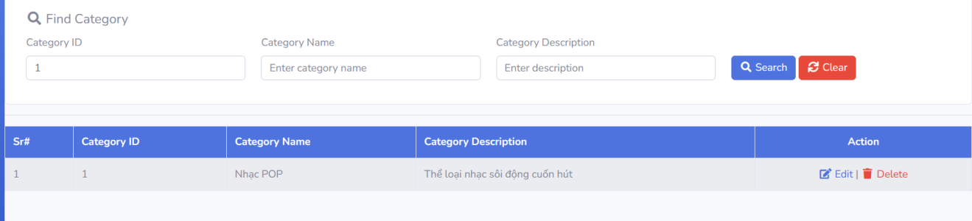

**Search by name:**

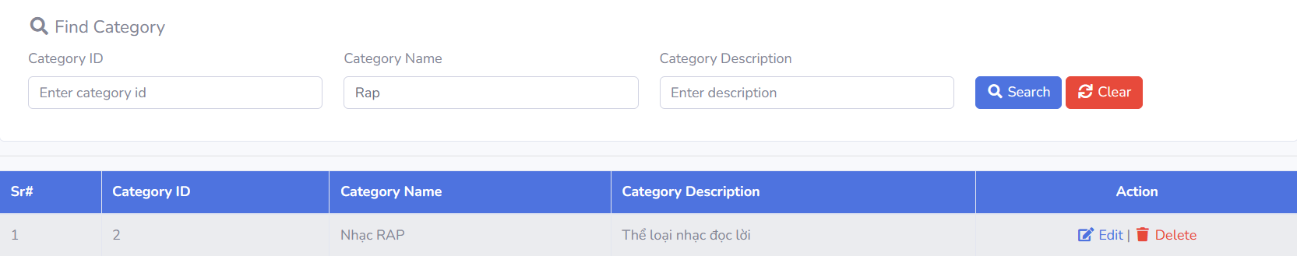

**Search by description:**

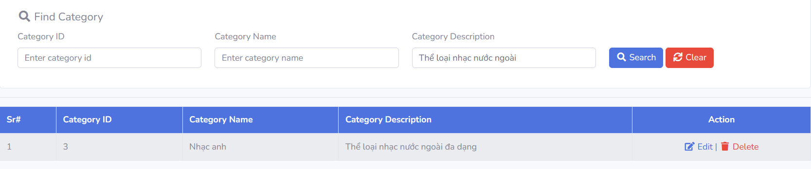**2. Add Function**

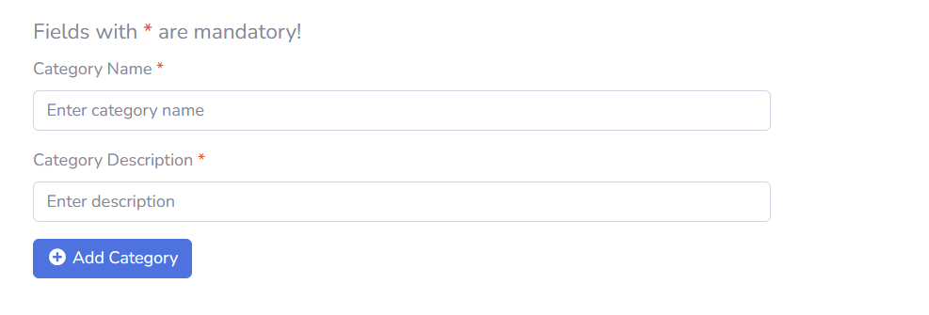

**Code:** admin_add_category.php

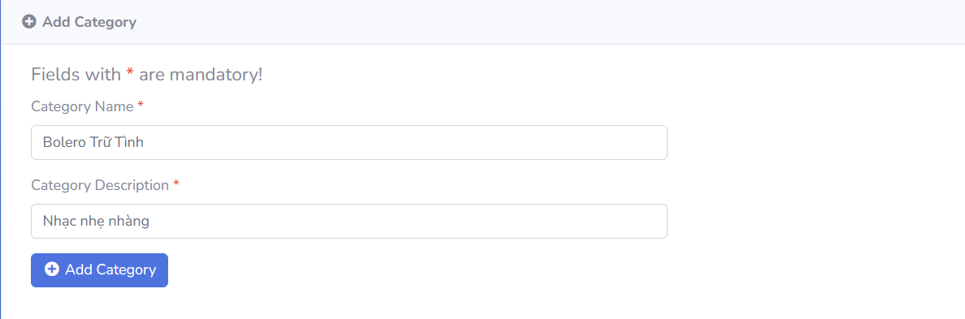

We fill in the name categories and description then click add, it will be added as shown

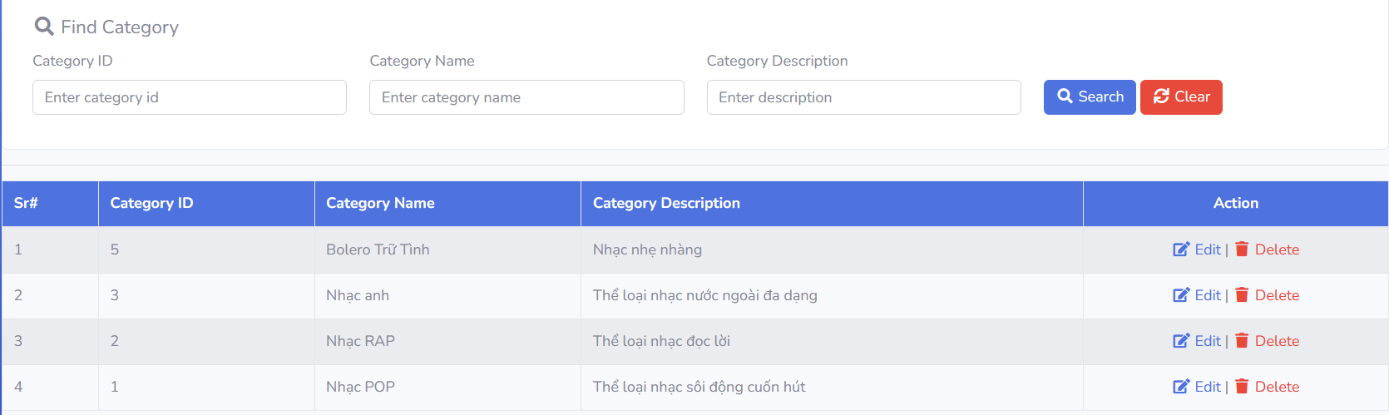

**3.Edit Function**

**Code:** admin_edit_category.php

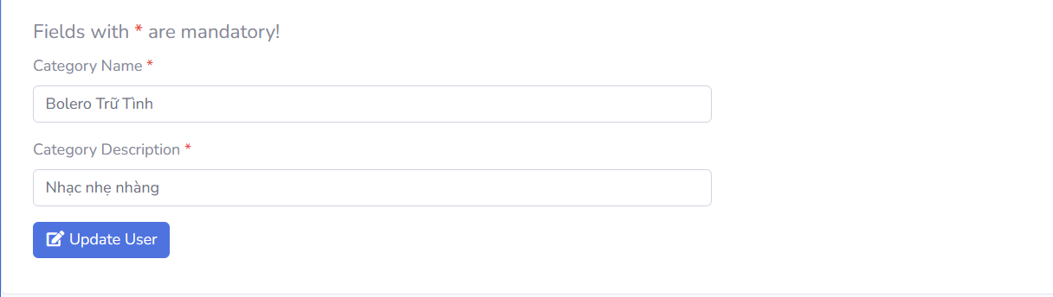

I will try changing the description and save it.

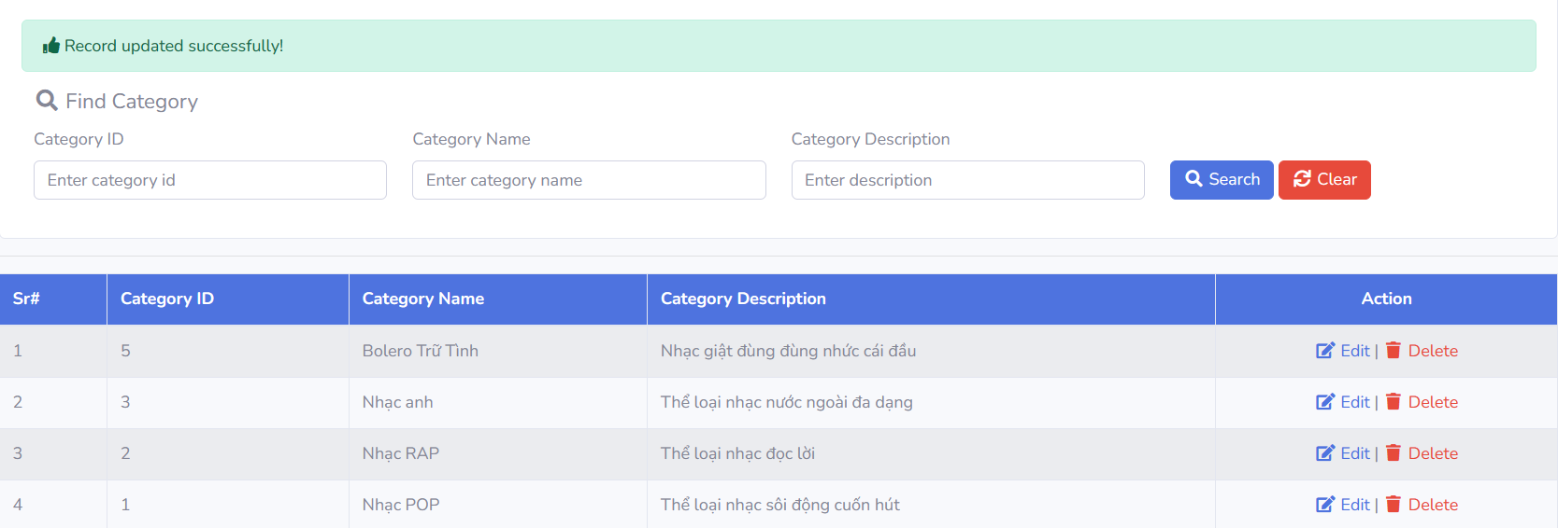

1. **Delete function:**

**Code:** admin_delete_category.php

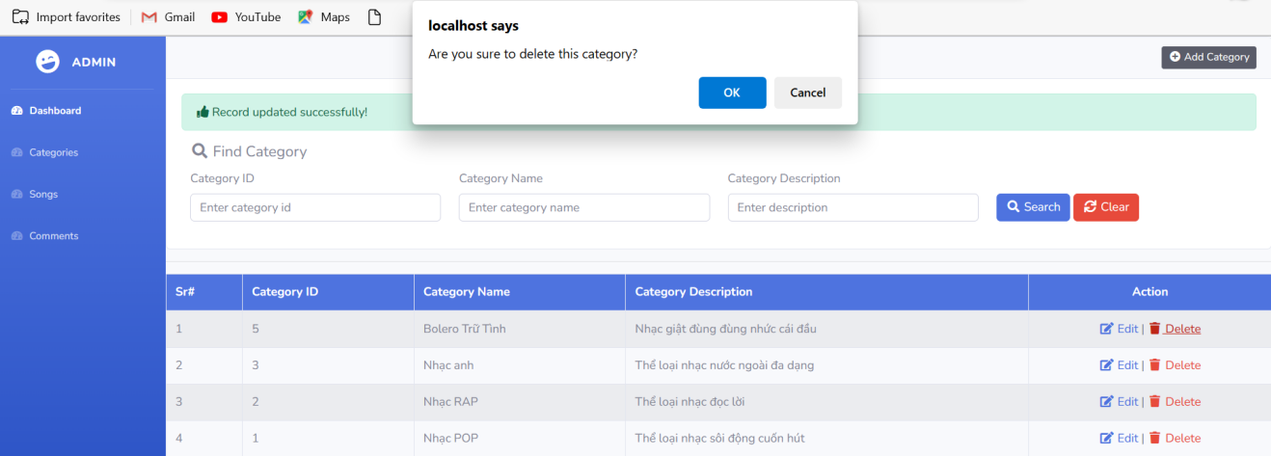

I will try deleting the category with id 5.

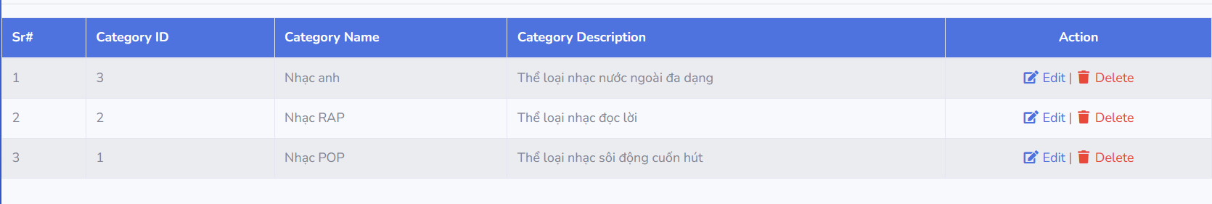

**3.3.2 Songs.**

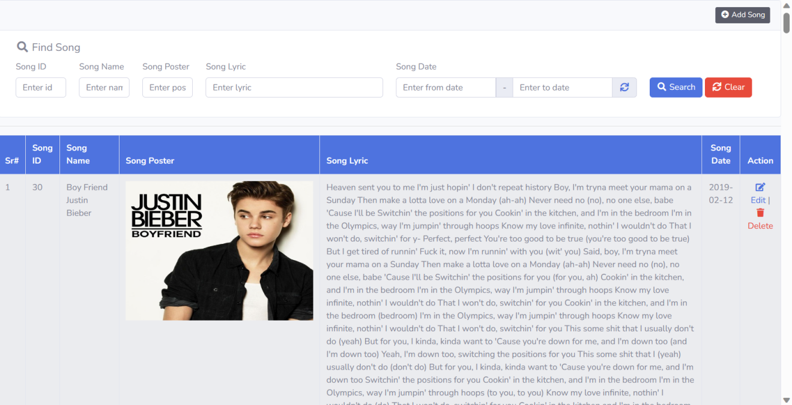

**Code:** admin_song.php

Similar to the category, songs also have the same functions.

1. **Find Songs**

Find songs by ID:

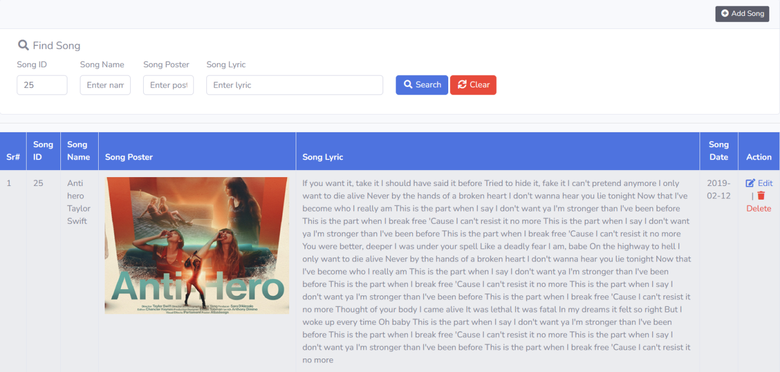

Find songs by Name:

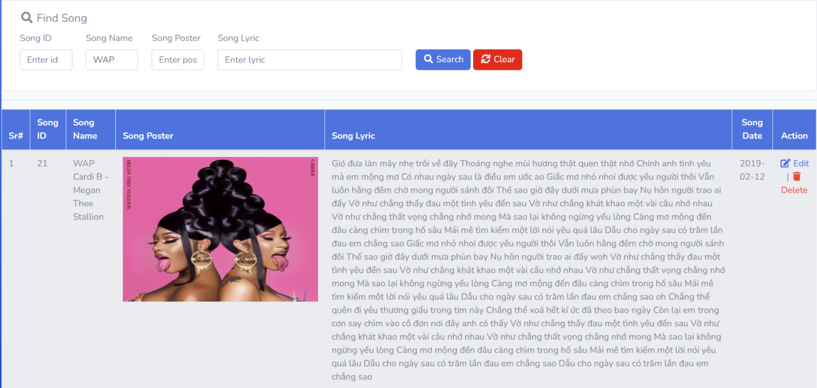

Find songs by Poster:

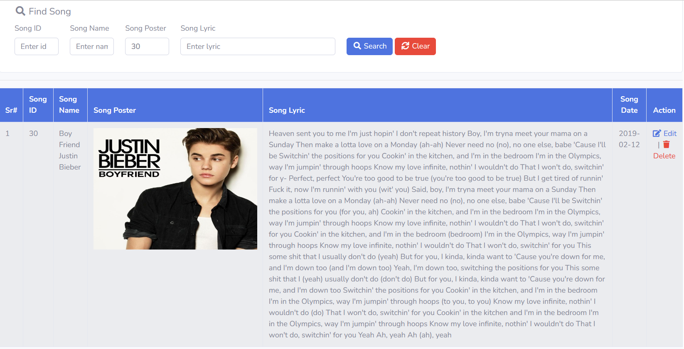

Find songs by Lyric:

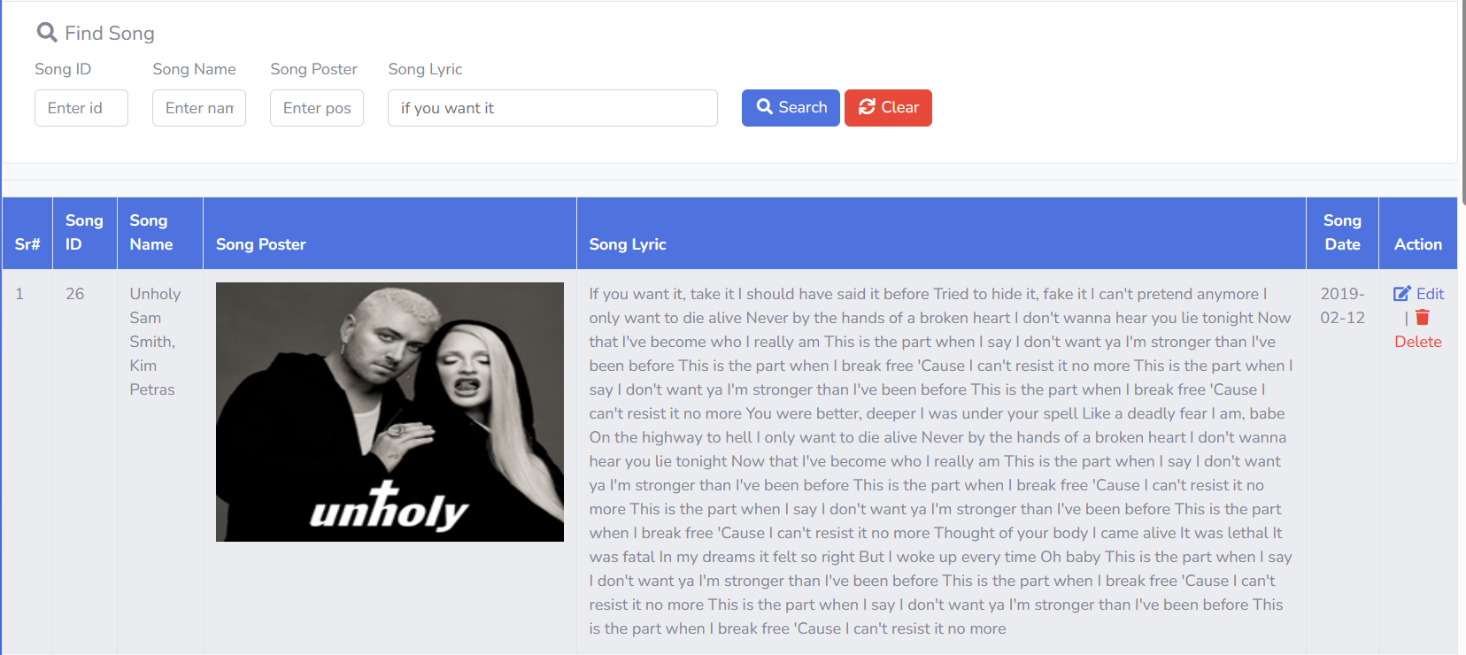

1. **Add Songs**

**Code:** admin_add_song.php.

We'll try to make a new song.

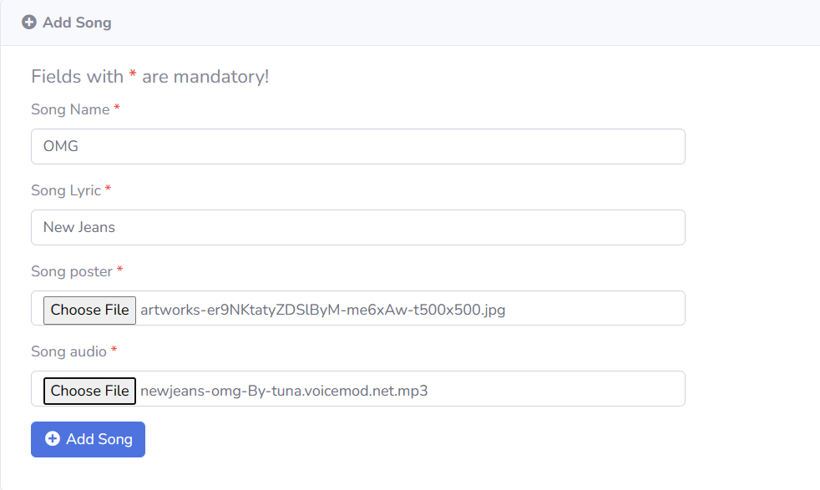

And here is the result after adding

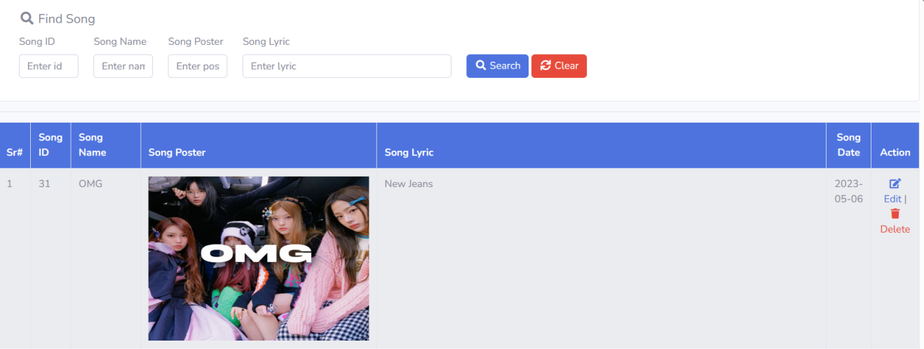

1. **Update Songs**

**Code:** admin_edit_song.php

The lyrics of the song are wrong so I'll correct the lyrics.

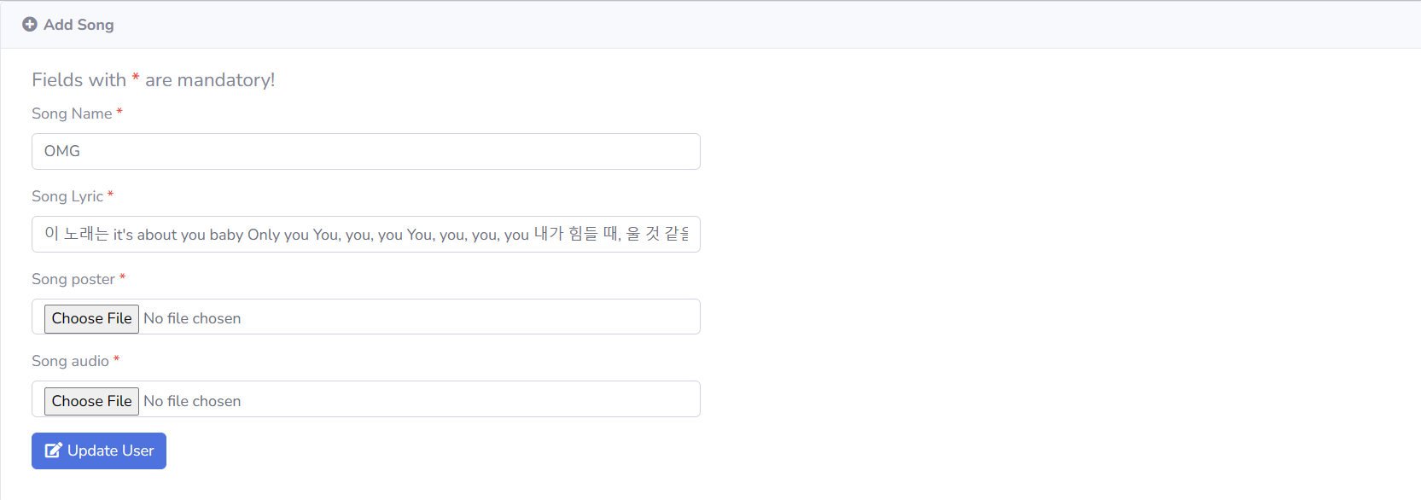

And here is the result after editing

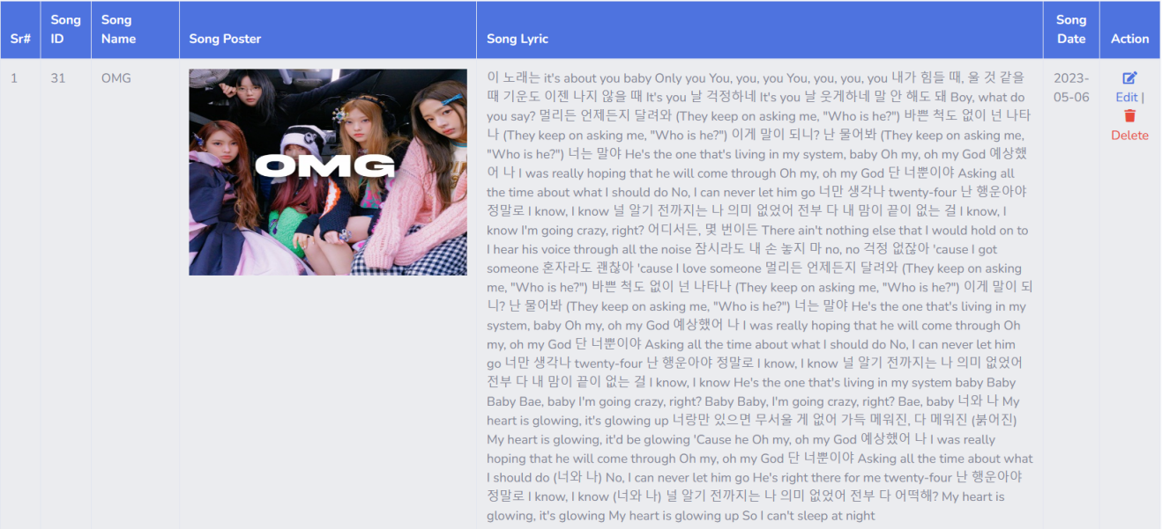

1. **Delete Songs.**

**Code:** admin_delete_song.php

I will try to deleting the newly created song.

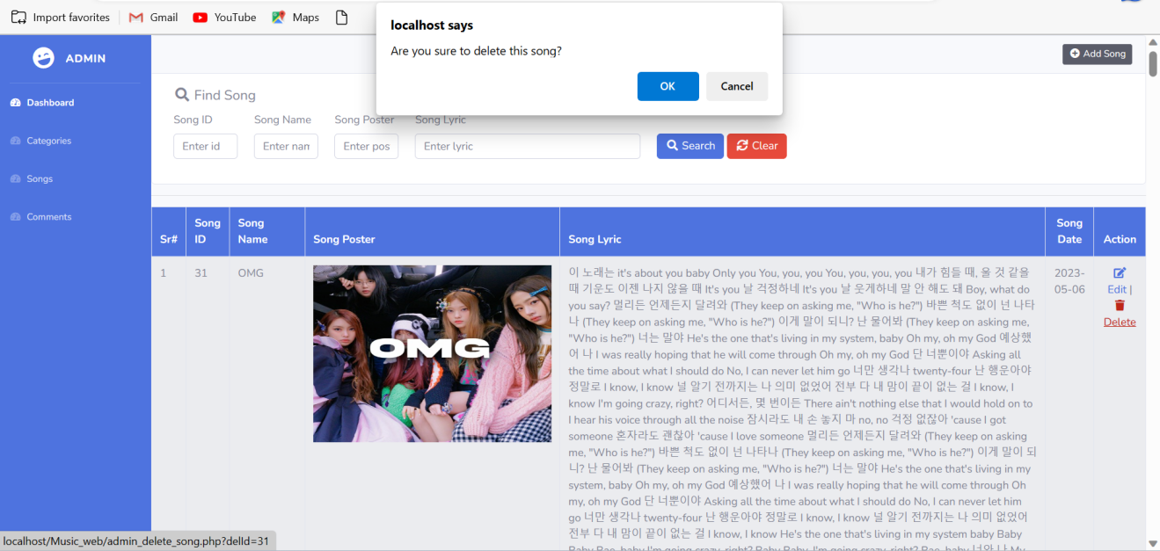

And this is the result.

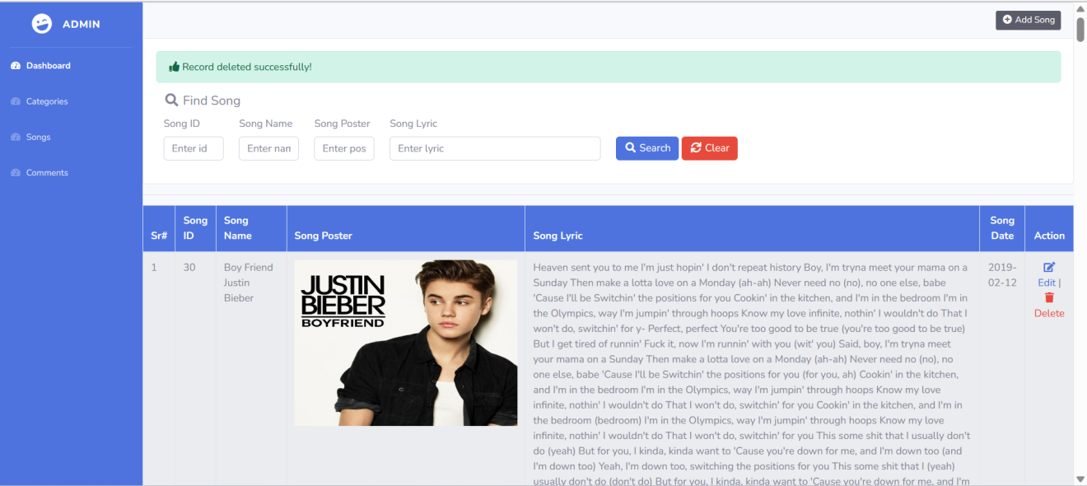

**3.3.3 Comment.**

**Code:** admin_comment.php

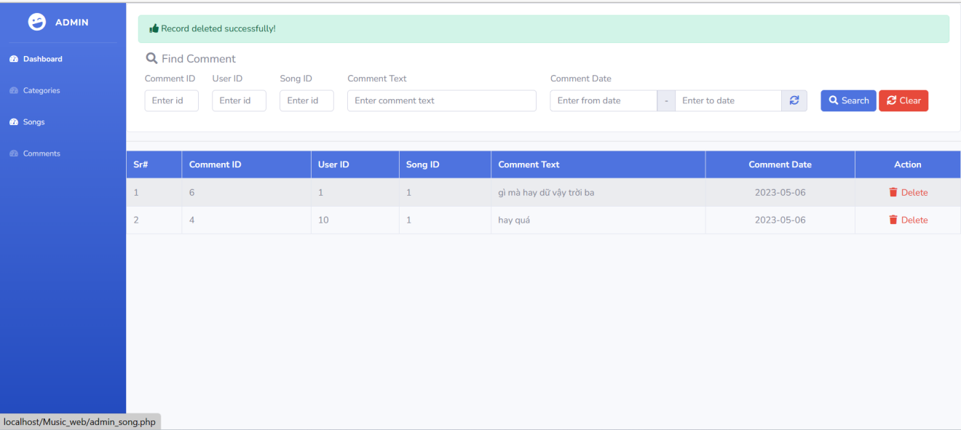In the comments, we have 2 functions: search and delete

1. **Search:**

Find comment by CommentID:

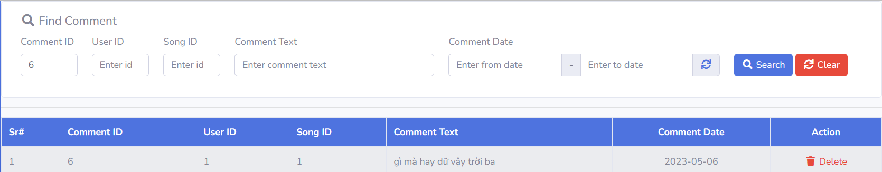

Find comment by UserID:

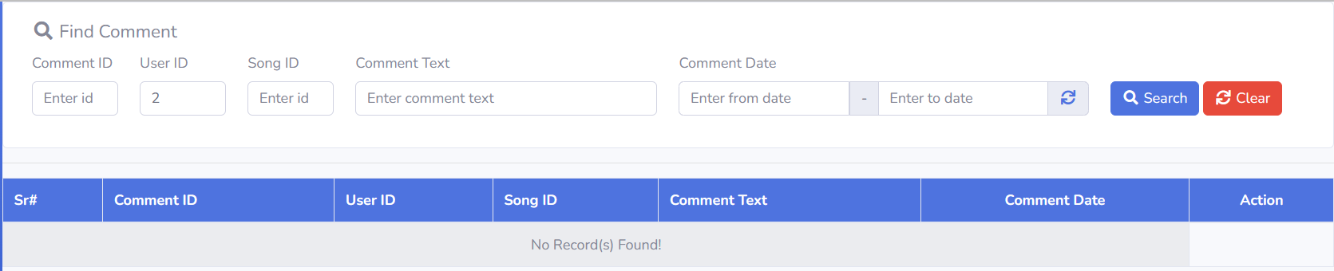

Find comment by SongID:

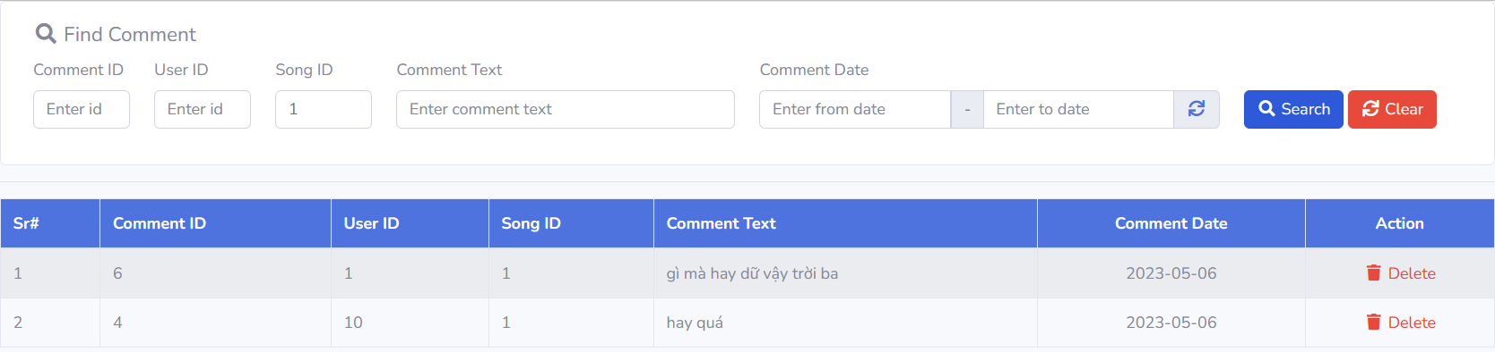

Find comment by Comment Text:

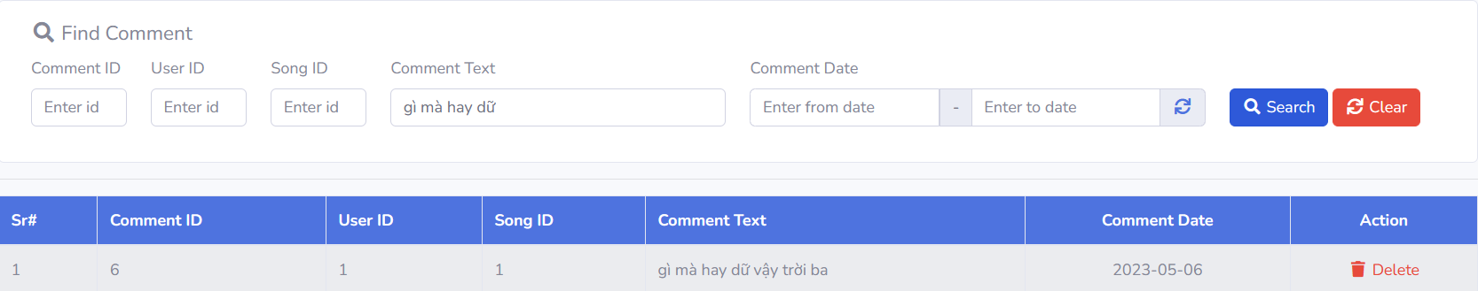

Find comment by Date:

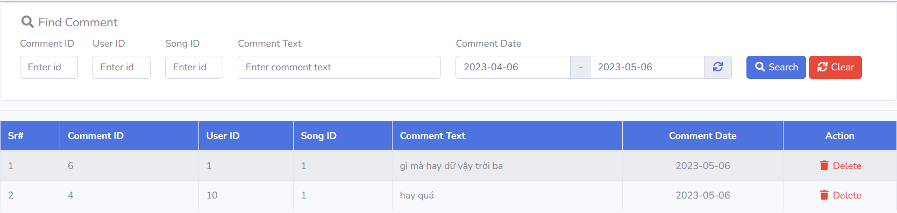

1. **Delete:**

This function has the function of deleting comments that you don't like or you feel are inappropriate.

**Code:** admin_delete_comment.php

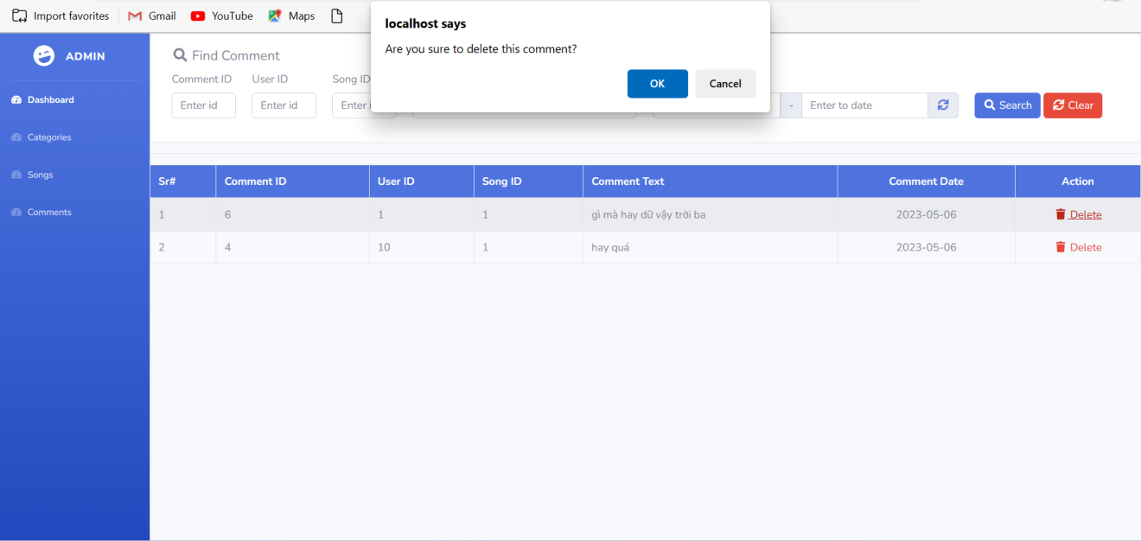

After delete the comment

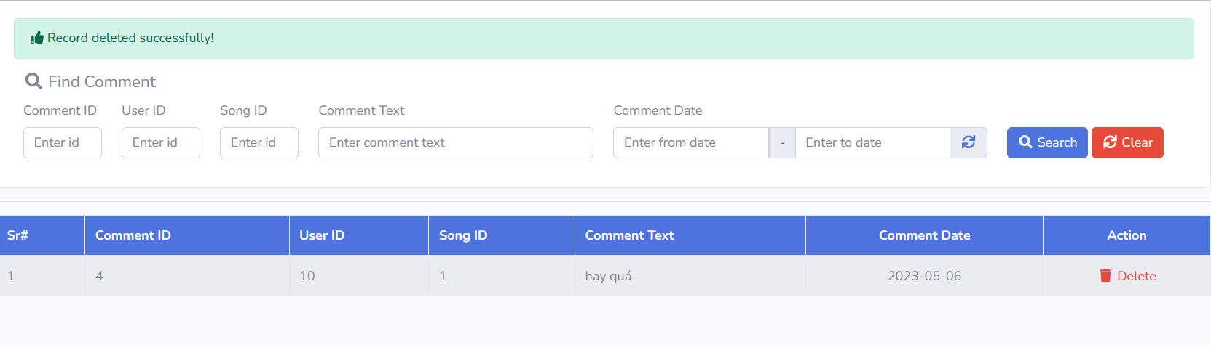

**3.4 User Form.**

**Code:** playlist.php

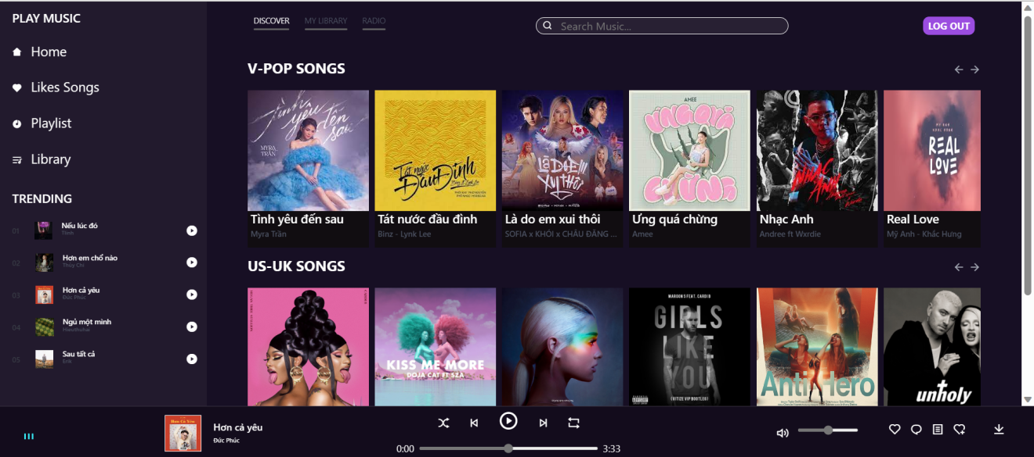

In the user homepage, we have the following main functions:

+ Listen to music

+ Skip and back music

+ like music

+ watch lyric

+ random music

+ Volume up and down

+ Comment

+ Download

Add some more advanced functions such as library, playlist and favorite songs where you can store your like songs

**Listen to music:**

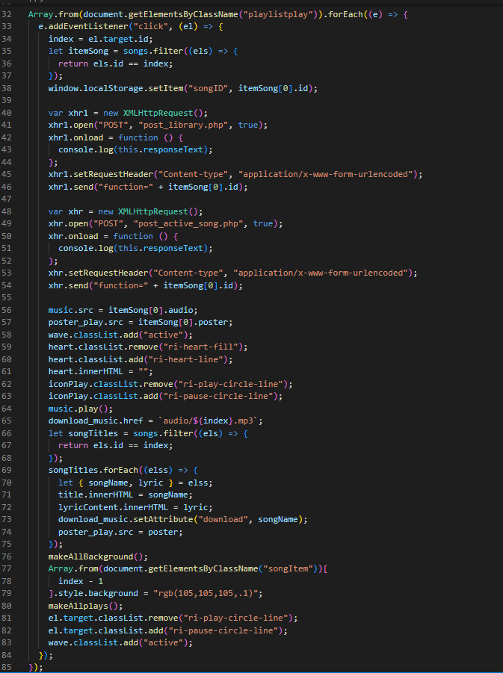

when we select any song on the screen interface, that song will be automatically played, for example we will choose the song " no tears left to cry " by ariana grande to listen.



The music bar will automatically change according to the interface of the song you are listening to, specifically here is the song of singer ariana grande.

**Skip and back music**

Continue with the example above if you want to go to the next song then press the 2 buttons on the music bar, which is marked as an arrow to the right.

After pressing, the song will automatically switch to the song "Girl like you".



Otherwise, we click on the remaining button, we will get the result to return the song of ariana grande



**Code:**

Back button:

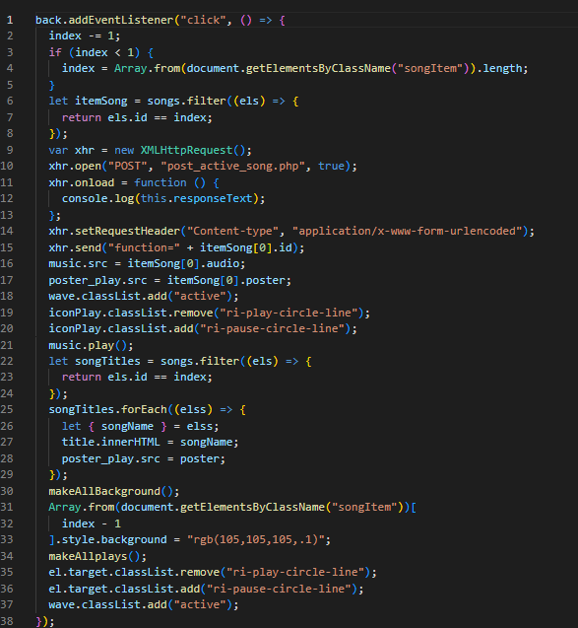

Next button:

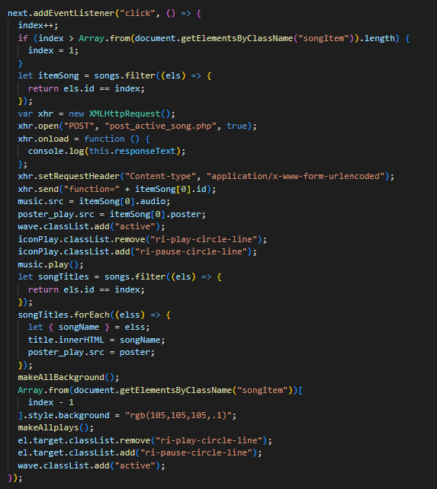

**Like music button:**

When you listen to a song that you love too much, and want to store that song in a place full of only your favorite songs, the like button will be very suitable in this situation, the function of This button is to help you store your favorite songs on a page containing only your favorite songs.



For example, if you love the song above and want to store it in favorites, now press the heart next to the volume bar, now the heart is filled, you have succeeded, this is also indirect add that song to your Favorite Songs.



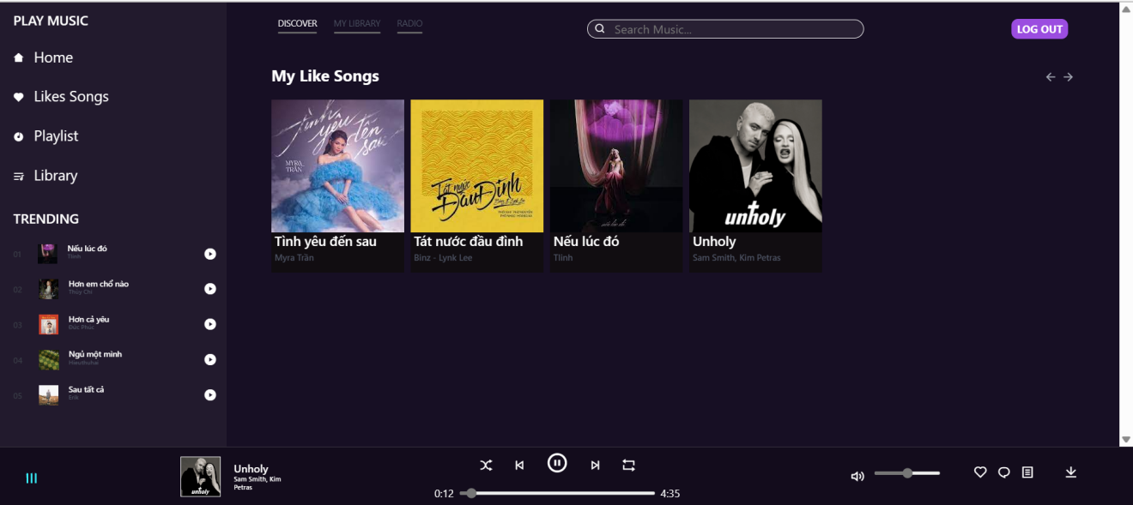

And you see, that song has been added to your favorites list.

**Code:**

Change heart icon:

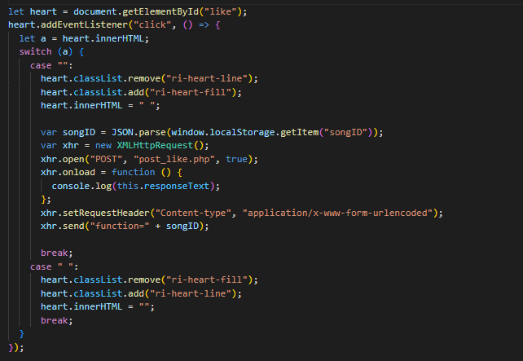

Add favorite songs:

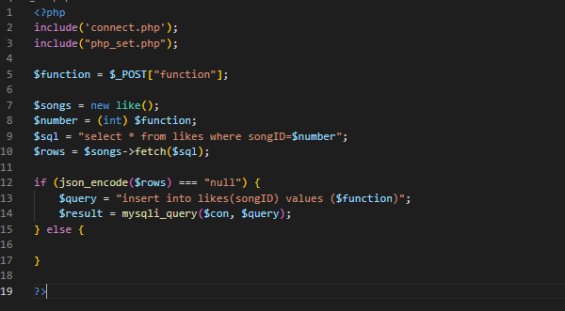

Show your like songs in favorite songs page:

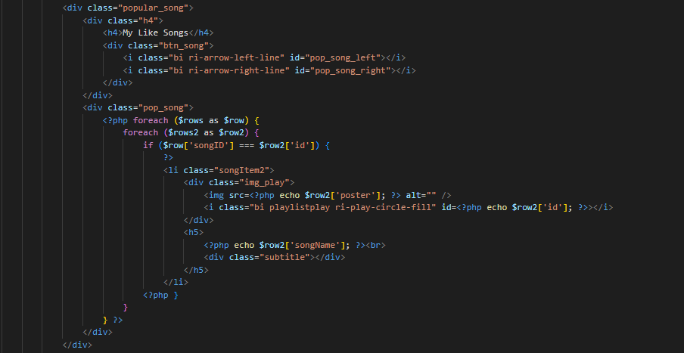

**Comment button:**

Next to the heart icon is the comment icon, where you can comment on what you love about that song from criticism to praise. Example of the song "Neu Luc Do" by singer Tlinh.



I will try to comment this song.

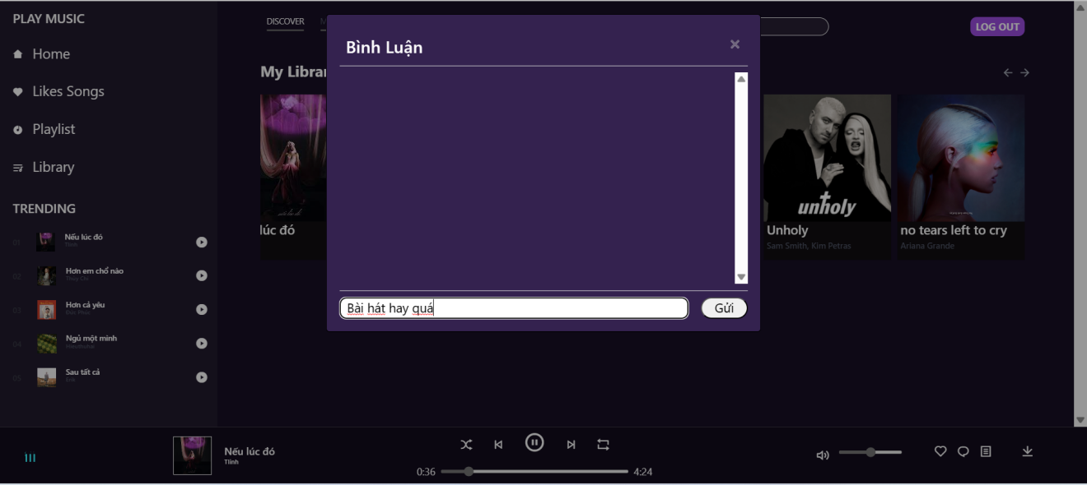

Wait a minute.

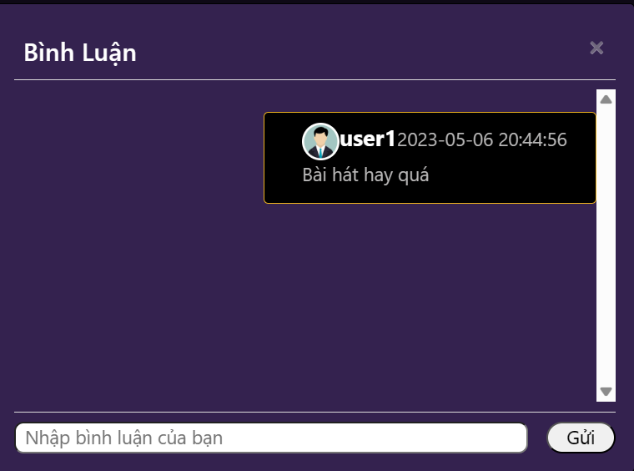

This comment has been uploaded to the database and displayed on the comment

**Code:**

Upload comments to the database

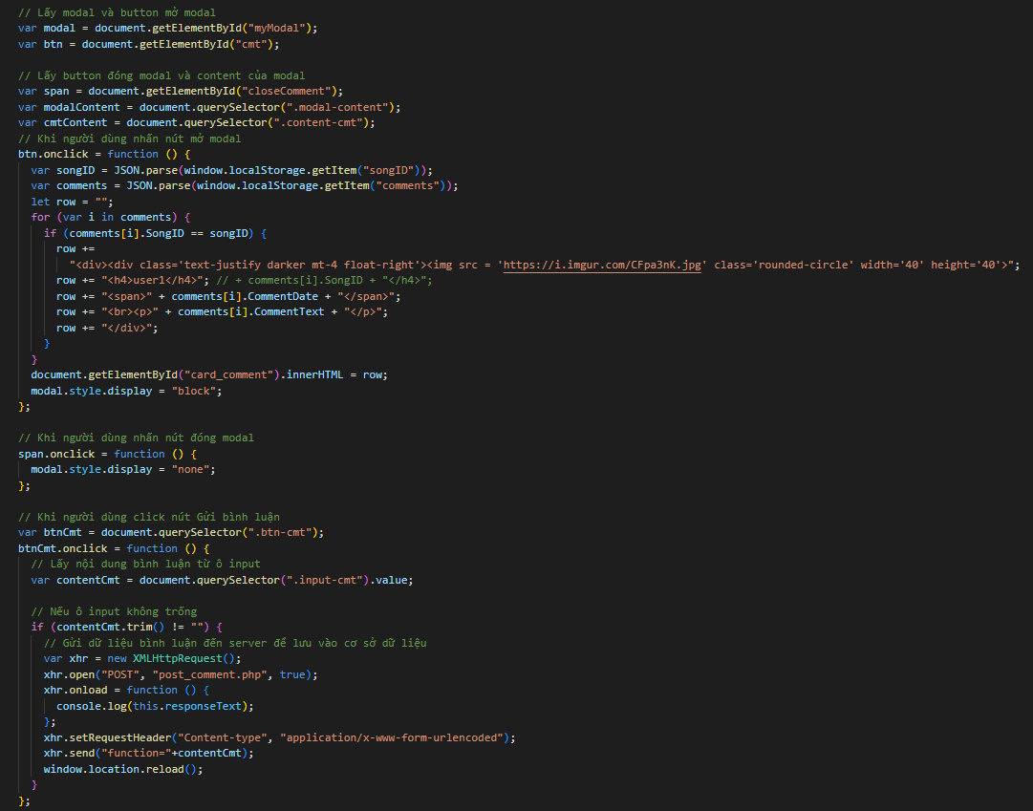

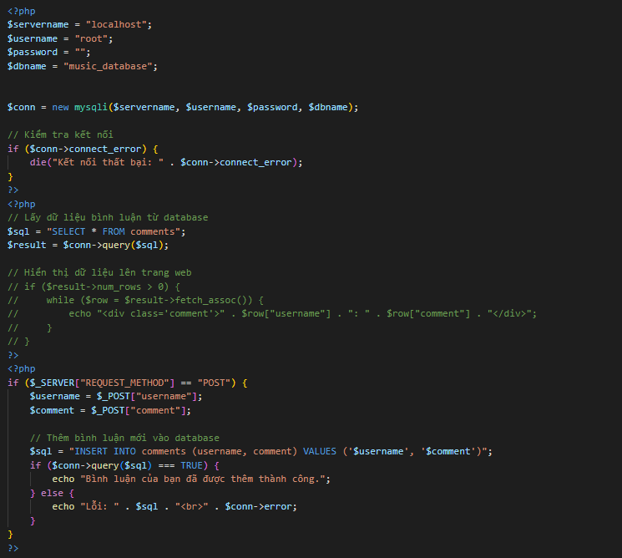

Show comment:

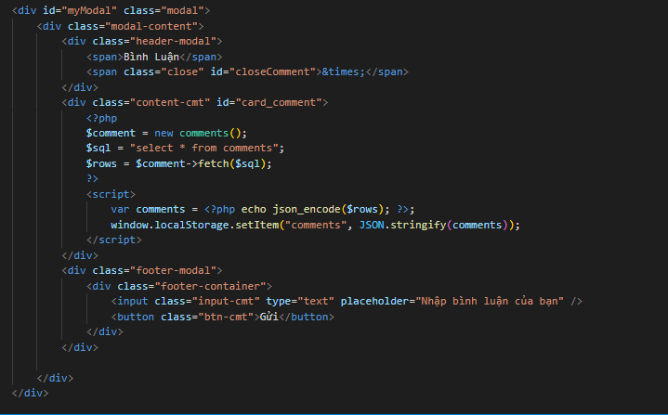

**Lyric:**

This function shows the lyrics of the songs, what you listen to, and the lyric button next to the comment button.

Example with the song "La do you unlucky" by female singer Sofia.

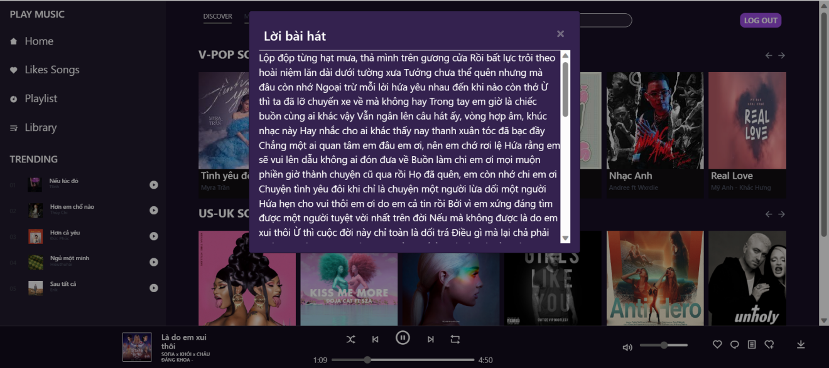

Code:

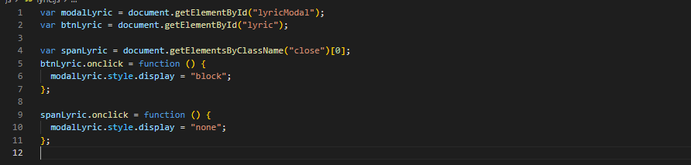

**Playlist button:**

The next button will be the playlist button, which allows you to create your own playlist. Also with the above example, we will press that button to add the song to my playlist



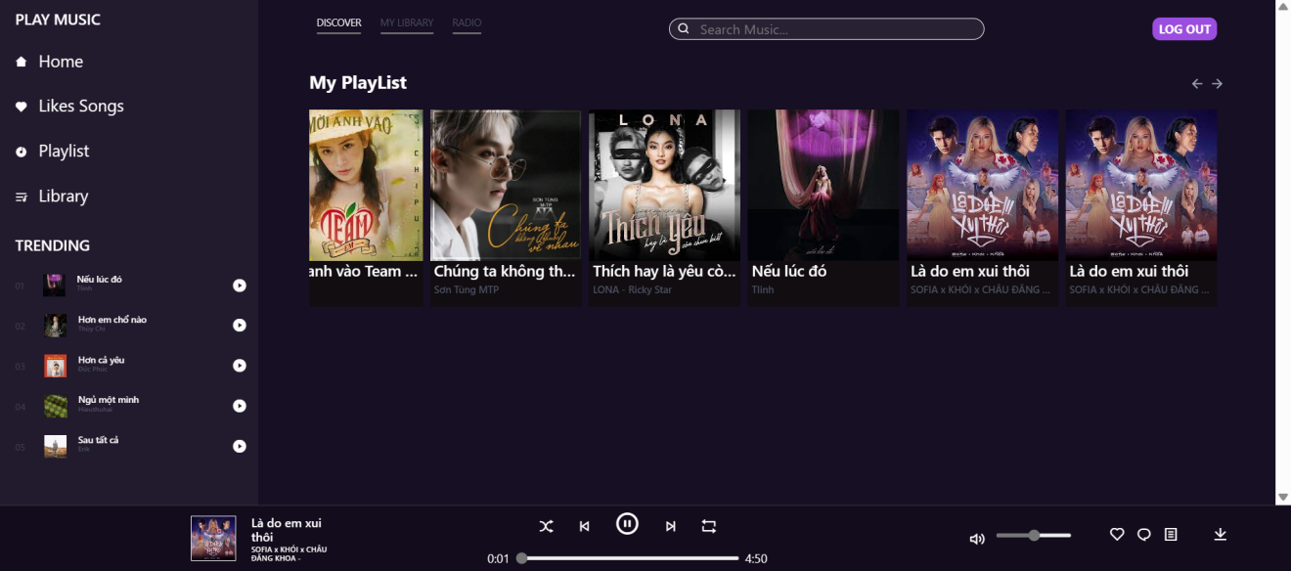

so the song was added.

**Code:**

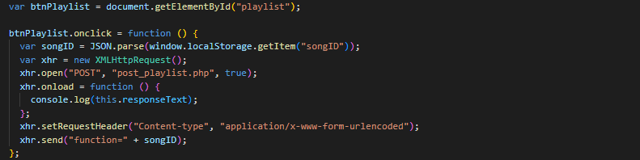

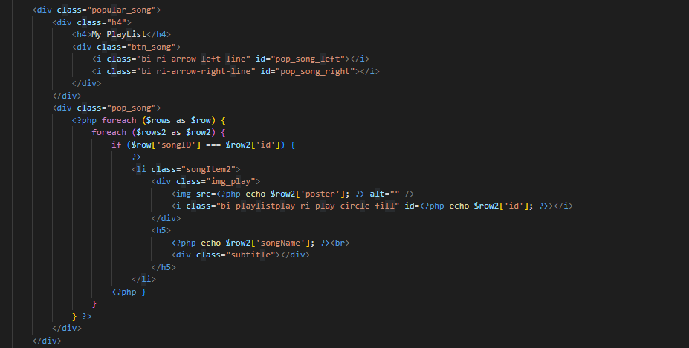

**Download button:**

The last button is the download button, which helps you to download your music to your computer, it is located in the right corner of the music bar.



click on the downloaded song.

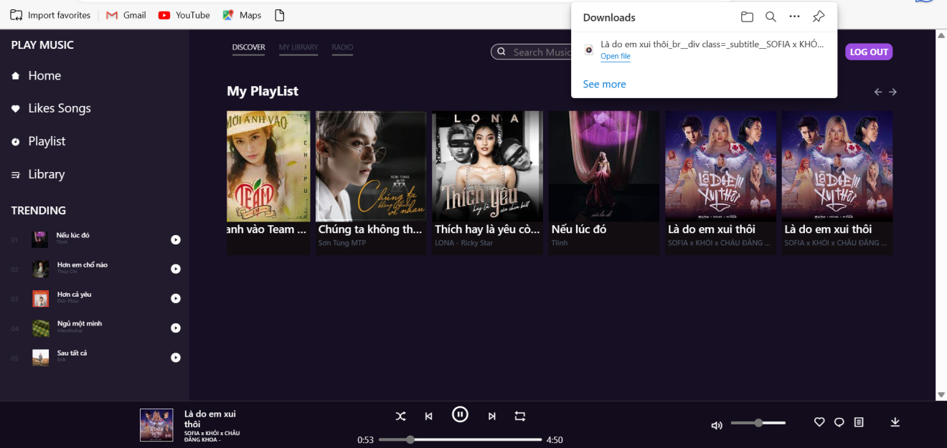

**Code:**

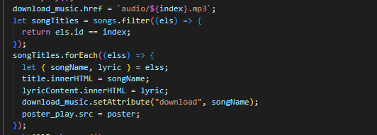

**Library function:**

A function that allows to store previously listened songs. For example, I will listen to the song "Moi Anh Vao Team Em"

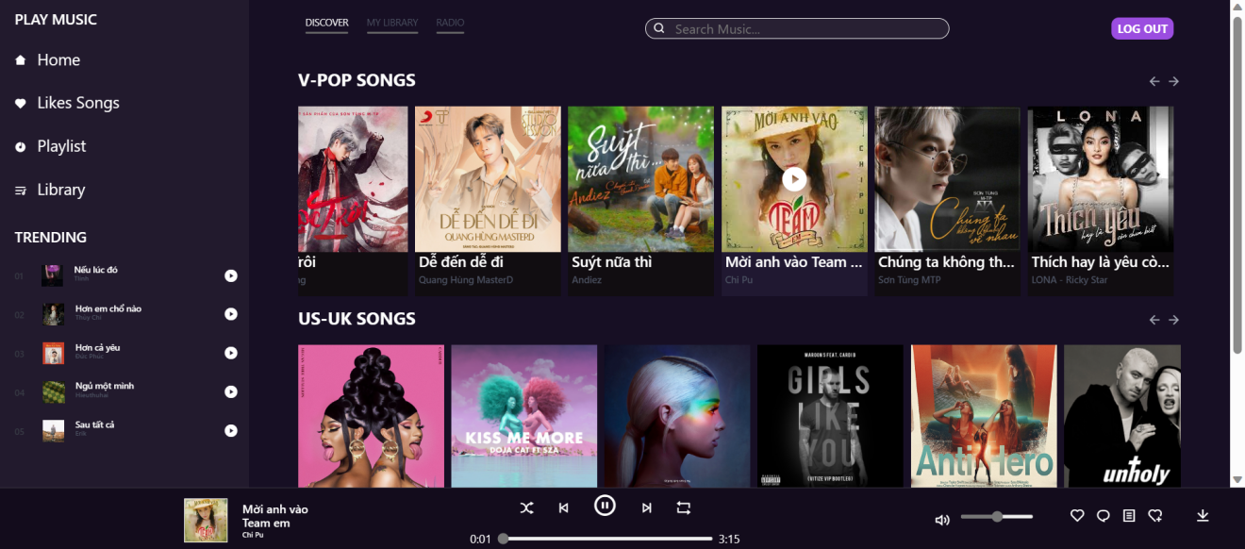

And when I go to the library page, my recently heard song will be moved to the bottom of the library

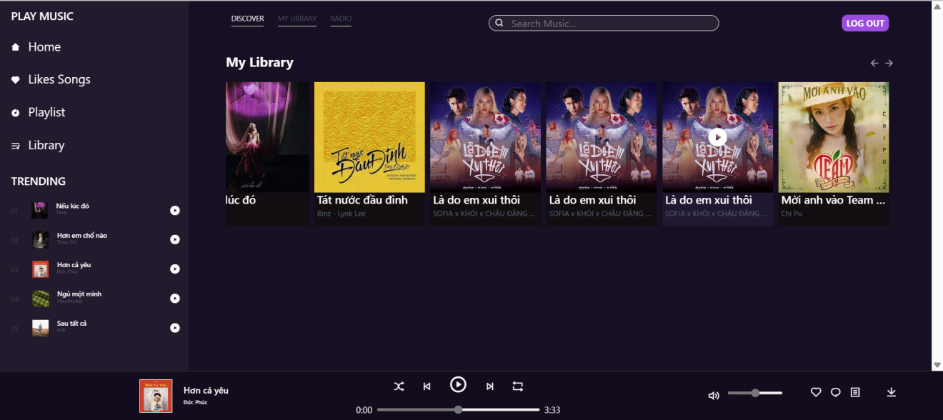

Code:

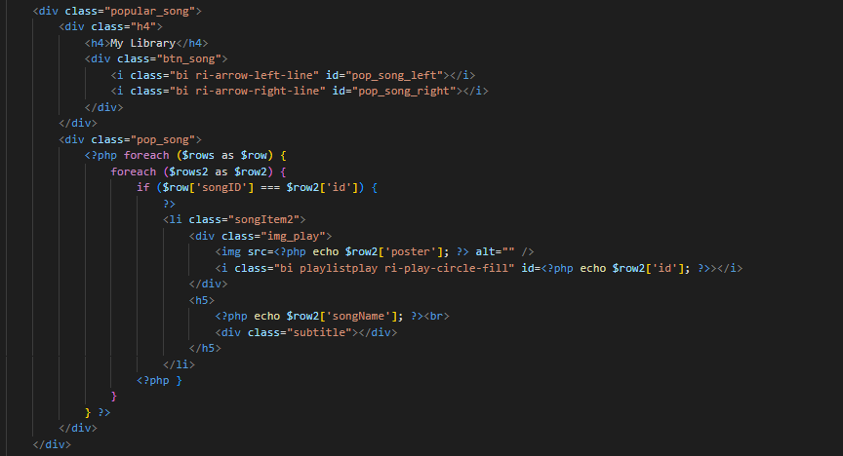

**Search function:**

This function is one of the most special functions of the music website and also the last one. This function allows us to find songs by name.

For example, I want to listen to a song "Positions" but I can't find it, then I will use this function to find it.

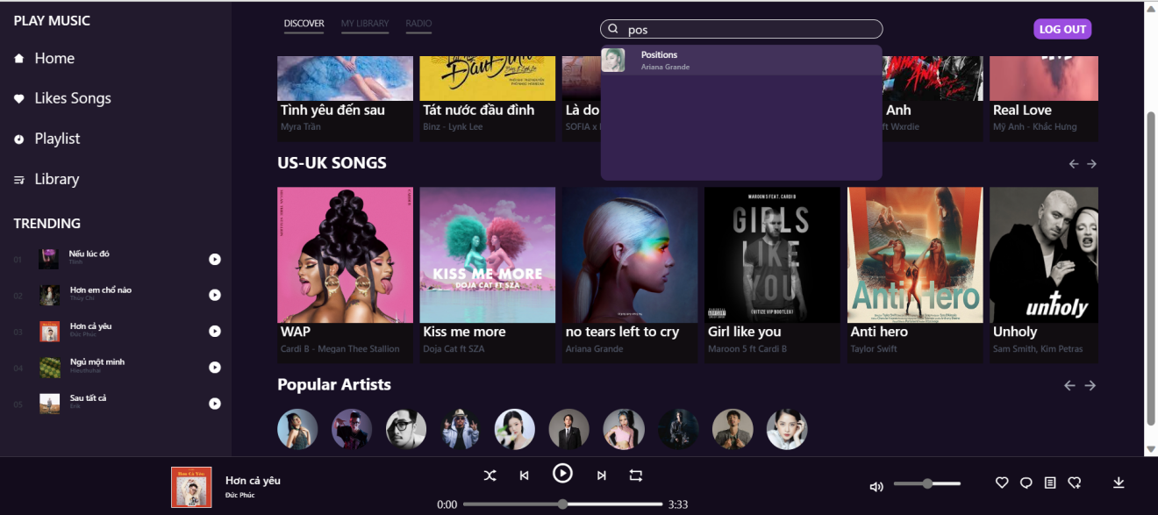

Just click and enjoy the music.

**Code:**

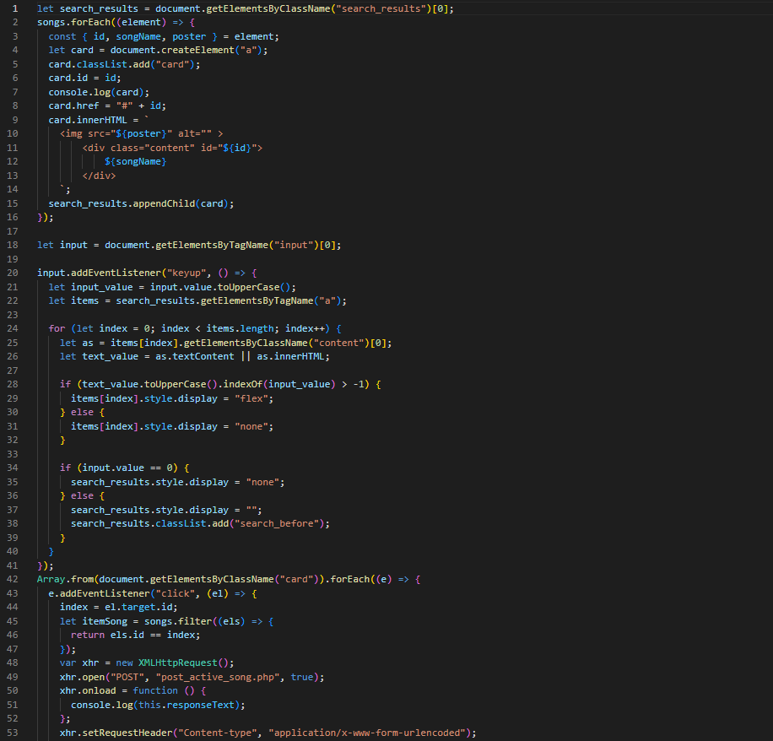

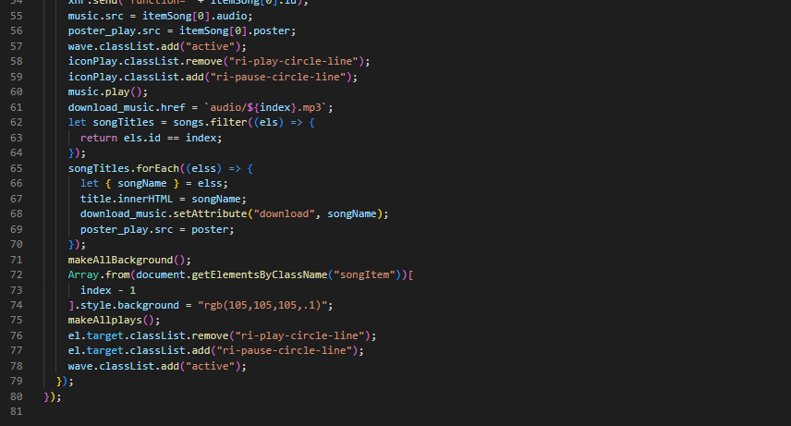

CHAPTER 4 - CONCLUSION

The language of music is universal and cuts over all national, religious, and cultural barriers. It has the incredibly strong ability to elicit strong emotions, foster creativity, and unite people from all over the world. It is a huge and varied world, with a wide variety of genres, artists, and styles to suit everyone's tastes. There is something for everyone, whether they enjoy listening to classical symphonies or headbanging to extreme.

Accessing new music, finding up-and-coming artists, and interacting with other like-minded fans globally have never been easier thanks to technological innovation. Users may now explore a vast range of music without leaving their homes thanks to platforms like Apple Music, Spotify, and YouTube. With only a few clicks, users may access millions of music and playlists produced by both professionals and amateurs.

Additionally, live shows and concerts are now more accessible than ever thanks to online streaming platforms. This makes it possible for people who are unable to travel to live events to still enjoy the enchantment of live performances.

There is always something new to learn, whether you are a seasoned music fan or someone who is just starting to explore the world of music. There are many chances in the music industry, from discovering new artists and genres to deepening your understanding of music.

In conclusion, the music industry is thriving and diverse, satisfying the musical preferences of everybody. Fans may communicate with one another, find new music, and expand their musical horizons thanks to technology. There has never been a better moment to begin discovering the marvels of music with so much wonderful talent waiting to be found.